ANNEX 15 - DESCRIPTION OF FLOWER AND BUNCH DEVELOPMENT STAGES IN MATOOKE

Table 1.1 Description of bunch development stages in Enzirabahima and Nakitembe matooke varieties
Variety | Stage of bunch growth | Photograph | Description
Enzirabahima  (seed fertile) | Erect |  | Bracts incompletely open while still in the erect stage. Flowers are not visible
 | Horizontal |  | Some bracts fully open while subsequent bracts continue to open partially. On fully opened bracts, flowers are visible
 | Semi-pendent |  | Bracts open fully, with 1-2 bracts open at a time
 | Semi-pendent | 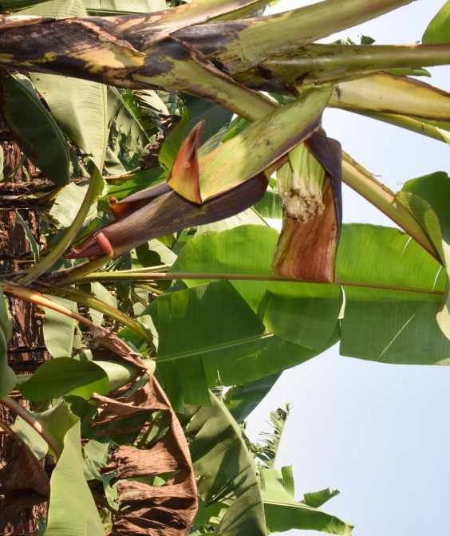 | Two bracts open simultaneously
 | Male bud appearance |  | Bracts open to full length and flower parts wither and fall off
Nakitembe  (Seed sterile) | Semi-Horizontal | 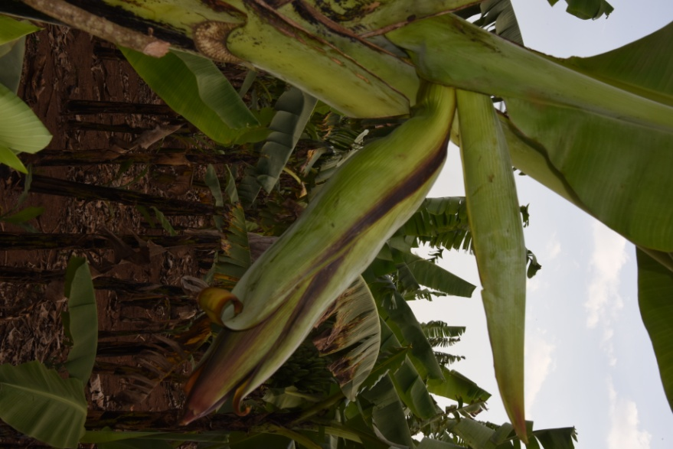 | Bracts open partially
 | Pendent | 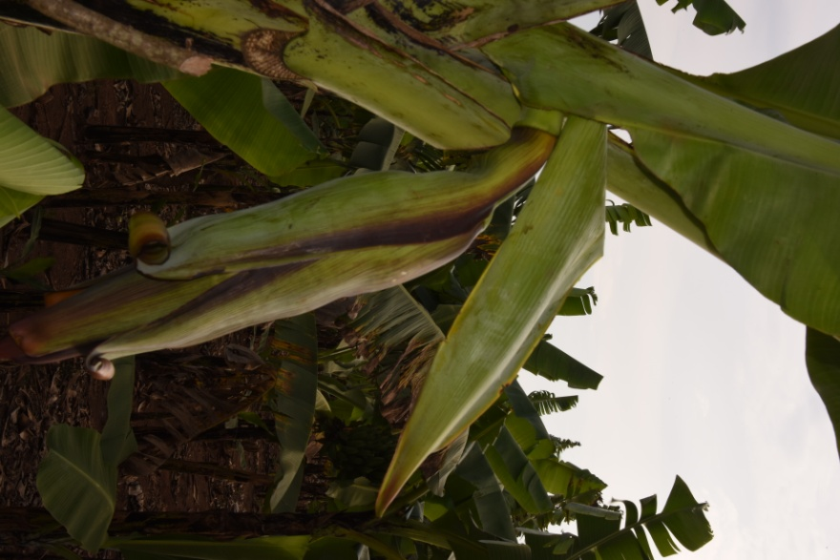 | Bracts open partially
 | Pendent | 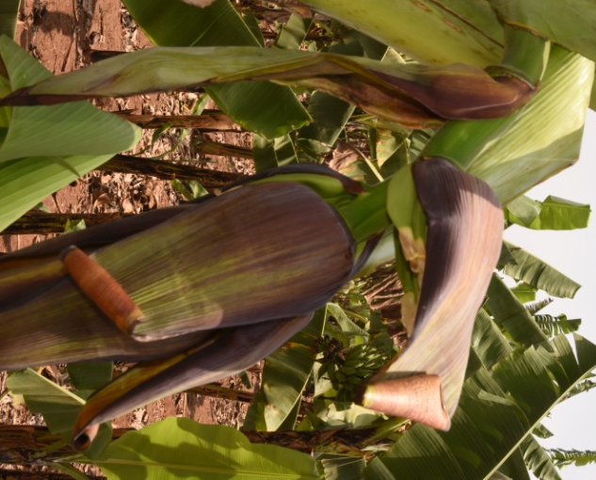 | Bracts do not open to full length; flowers are visible
 | Male bud appearance |  | Bracts on male buds open but do not roll back to full length. Flower parts wither but remain persistent

