ANNEX 16 - DESCRIPTION OF FLOWER DEVELOPMENT STAGES IN MCHARE

Table 3.1 Description of bunch development stages in Mlelembo, a Mchare variety
Variety | Stage of flower growth | Photograph | Description
Mlelembo  (seed sterile) | Erect | 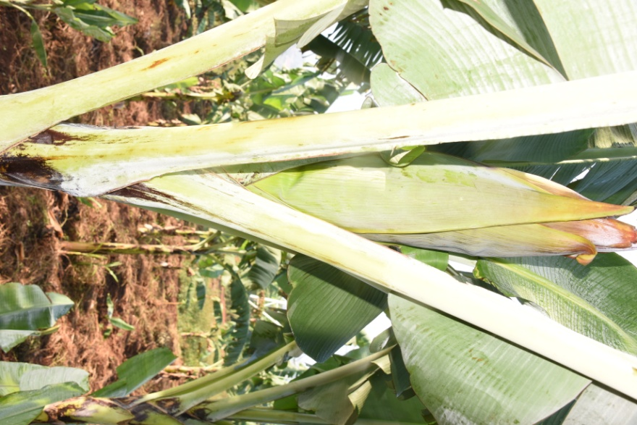 | A number of bracts start opening
 | Erect | 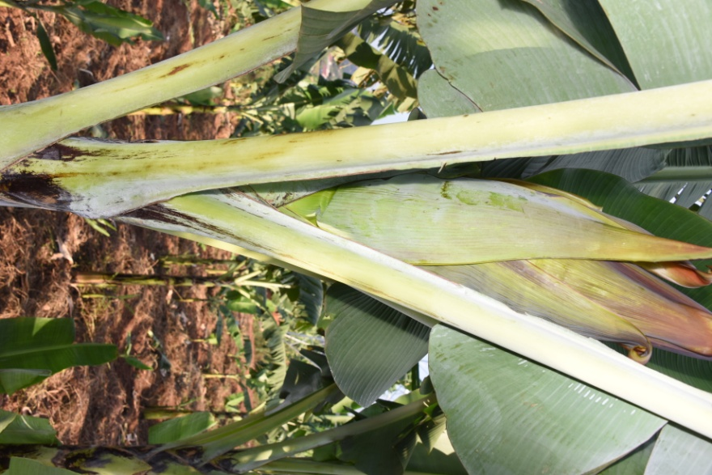 | Several bracts open but not to full length
 | Horizontal |  | Several bracts continue to open but not to full length. Flowers become visible
 | Pendent | 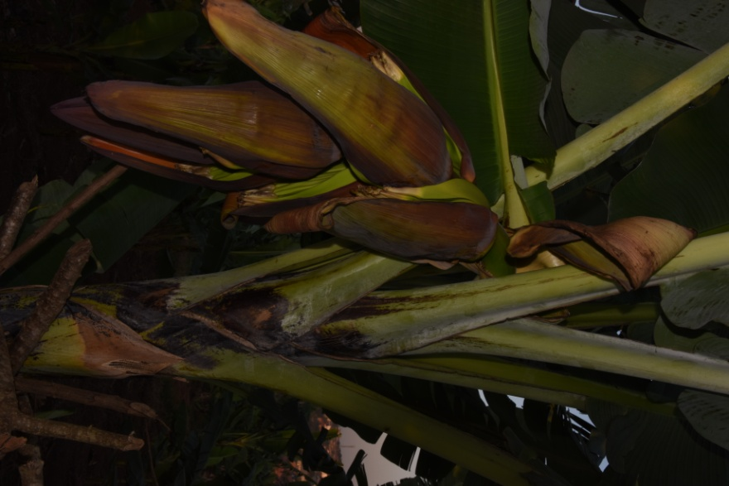 | All bracts open but not to full length while the bench is in the down position
 | Male bud appearance |  | Bracts on male buds open but do not roll back to full length. Flower parts wither but remain persistent

