Bioversity INTERNATIONAL Progress report
For the project
‘IMPROVEMENT OF BANANA FOR SMALLHOLDER FARMERS IN THE GREAT LAKES REGION OF AFRICA’
Reporting period: 1 October 2016 – 31 March 2017 (period 5)

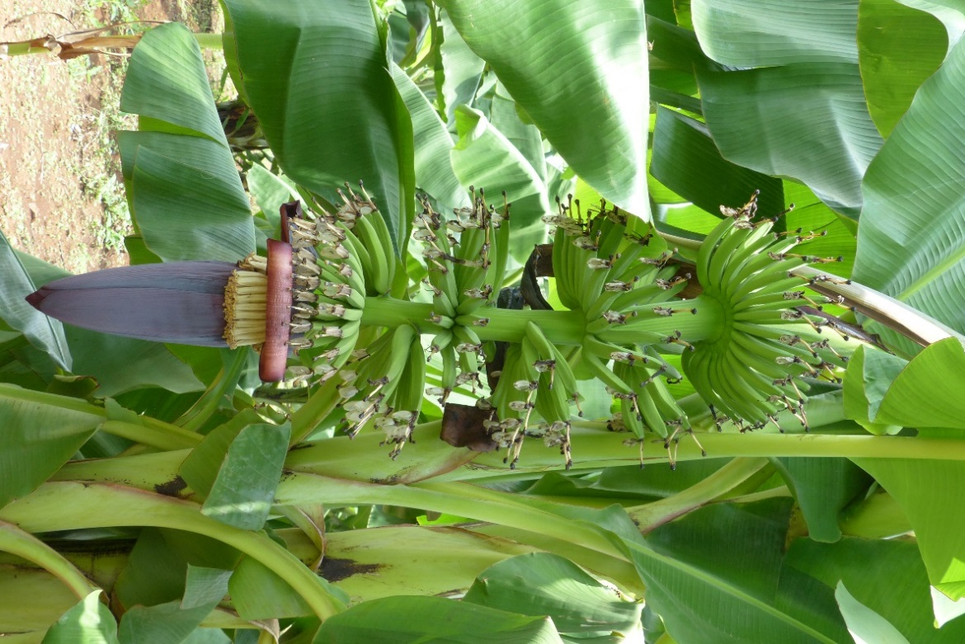

Report outline

1. Executive summary 1
2. Primary outcomes, intermediate outcomes, outputs and milestones 2
3. Results to date 6
4. Challenges encountered 9
5. Lessons learned 9
6. Workplan 9
7. Budget summary 9
8. Other relevant project information 9

In Memoriam

On 07 March 2017, the project lost one of its champions, Mr Mgenzi Byabachwezi.
Mgenzi was the Principal Agriculture Research Officer of the Maruku Agricultural Research Institute (ARI-Maruku) and Leader of the Tanzanian National Banana Program.
In this project, he was one of the five site coordinators for the multi-location evaluation of the NARITA hybrids. His knowledge of banana production systems and his unmatched skills to work with local banana-producing communities were crucial in the successful conduct of the baseline study in the project’s action sites, which will continue to inform banana breeding efforts for many years to come.
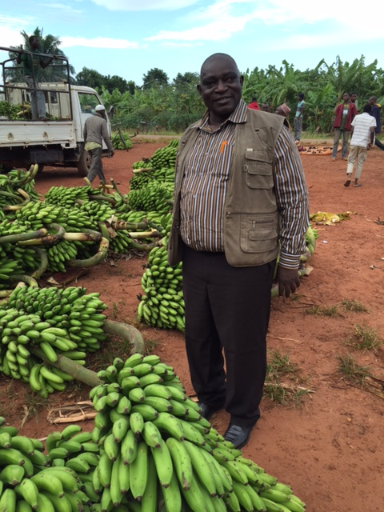

Full of energy and humour at work, Mgenzi made every task look easy and enjoyable, especially when working with smallholder farmers in rural areas.
Dear Mgenzi, we will never forget you.

~~~

1. Executive summary
This report summarizes the progress and outputs achieved by Bioversity International during the fifth 6-month period (1 October 2016 to 31 March 2017) of the 5-year project on ‘Improvement of banana for smallholder farmers in the Great Lakes region of Africa’. Bioversity International is involved only in work package 4 (WP4), Regional Testing, which it also coordinates. The report therefore focuses on the activities and achievements of Bioversity International and partners in this work package. In citing the expected outcomes, actual outcomes, outputs and milestones, the report articulates work package results to date, challenges encountered, lessons learned, and the work plan for future activities.
Results
Outcome 4: Breeders have a better understanding of traits of importance to end users and use this to orientate breeding strategies and early selection processes
The data of the baselines study are being cleaned, sorted and coded. The data analysis pipeline has been set up and R code is being written to generate descriptive statistics and plots. The work on the baselines data analysis and compilation of the technical report, and papers, will be a dominating activity of 2017. A systematic literature review to assess the scope of published and grey literature on gender-differentiated banana trait preferences across the value chain is being conducted.
Outcome 5: Simplified, standardized protocol and tools for trial design and implementation, data collection and sharing implemented by all partners allowing meta-analyses across sites
The banana trait ontology, developed in collaboration with WP5 and WP1 and WP2, was uploaded to the Crop Ontology website (http://www.cropontology.org/ontology/CO_325/Banana). After the data collection protocols workshop held in September 2016, and the final labelling of the plants in each site with the QR codes, the data collectors took practice data from October-December, and final issues in the mobile data collection system were ironed out. A server was set up to host the mobile data from the five field sites: https://bio.smap.com.au/ .
Outcome 6: Farmers participating in selection of new hybrids, with feedback driving changes to strategy and selection processes of breeding programs to improve tailoring of future improved hybrids
Data collection is in full swing in the five field sites and will be ongoing for the rest of the project. Each month, the data collectors send the data they have collected to the server, and the data are being reviewed to provide timely feedback on data quality and encountered issues.
Outcome 7: Farmers across Uganda and Tanzania and beyond growing their preferred NARITA cultivars, alongside local cultivars
Since they were launched, the Musapedia page on the NARITA hybrids and the individual NARITA factsheets on the ProMusa website received over 2500 page views. Discussions have been initiated with RTB cluster CC2.1 to see how the methods developed for seeds systems analysis can be applied to the project, to inform upcoming activities on the dissemination of selected NARITAs in the target regions.

2. Primary outcomes, intermediate outcomes, outputs and milestones
Table 1 gives the Framework and Results Tracker for WP4, as adjusted in October 2016 (see final report year 2).
Table 1. Framework and results tracker for WP4.
 | Primary Outcomes |  | Intermediate Outcomes |  | Outputs | Targets/ Milestones
 |  |  |  |  |  | YEAR 1 | YEAR 2 | YEAR 3 | YEAR 4 | YEAR 5
4 | Breeders have better understanding of traits of importance to end-users and use this to orientate breeding strategies and early selection processes | 4.1 | Farmer and consumer needs and preferences in target population environments (TPEs) documented and important traits identified | 4.1.1 | Target population environments (TPEs) defined and characterized in terms of agro-ecological parameters | na | na | Agro-ecological characteristics of TPEs mapped out | na | na
 |  |  |  | 4.1.2 | TPEs defined and characterized in terms of socio-economic parameters | Database of gender-disaggregated socio-economic indicators of EAHB production systems in TPEs | na | MSc study on baseline study successfully completed | na | na
 |  |  |  | 4.1.3 | Key factors determining germplasm adoption in target region identified | na | na | Review paper on status, impact and constraints of previous germplasm introductions in target region | na | na
5 | Simplified, standardized protocol and tools for trial design and implementation, data collection and sharing implemented by all partners allowing meta-analyses across sites | 5.1 | Simplified and standardized protocol and tools for trial design and implementation, data collection and sharing tested and refined by project partners | 5.1.1 | Mutually agreed framework for project implementation developed by partners | Objectives, approach & activities, expected outputs & outcomes, roles & responsibilities, timelines discussed and clarified | na | na | na | na
 |  |  |  | 5.1.2 | Standardized protocol for mother and baby trials implemented by all partners | na | Standard protocol for mother and baby trials, including data collection, agreed on between partners | na | na | na
 |  |  |  | 5.1.3 | Handheld electronic data collection tool, linked to common database, used by partners for standardized data collection from all project field trials | Electronic data collection tool developed | na | Link between electronic data collection tool and database explored | na | na
 |  |  |  | 5.1.4 | Project partners trained in standard protocols and the use of the data collections tool | na | Hands-on training on standard protocols and the use of the data collections tool organized for partners of different project sites | na | na | na
6 | Farmers participating in selection of new hybrids, with feedback driving changes to strategy and selection processes of breeding programs to improve tailoring of future improved hybrids | 6.1 | 27 NARITAs distributed for further evaluation in Tanzania and Uganda | 6.1.1 | In vitro multiplication of virus indexed stocks of 27 NARITAs for distribution from ITC-Leuven | Accessions introduced in ITC and pre-screened | Virus screening ongoing | Health status of hybrids determined, and infected accessions cleaned | na | na
 |  | 6.2 | Agronomic, post-harvest and sensory characteristics of 27 NARITAs in researcher-managed mother trials and preference analysis by farmers in Tanzania and Uganda | 6.2.1 | Mother trials of 27 NARITAs and control genotypes successfully established at 3 sites in Tanzania and 1 site in Uganda | Plantlets multiplied to sufficient numbers (60 plants per genotype per site) | Plantlets hardened for field planting  Five field sites prepared and planted according to established design | Five field sites maintained according to established practices | Five field sites maintained according to established practices | na
 |  |  |  | 6.2.2 | High quality data obtained from 27 NARITAs and control genotypes evaluated for agronomic performance, bunch characteristics, post-harvest and sensory characteristics, from first crop cycle in researcher-managed trials at 3 sites | na | na | Data collected of first cycle, vegetative growth phase | Data collected of first cycle, vegetative growth, flowering and harvest  Fruits first cycle analysed for post-harvest and sensory traits, both fresh and processed products | na
 |  |  |  | 6.2.3 | High-quality data obtained from 27 NARITAs and control genotypes evaluated for agronomic performance, bunch characteristics, post-harvest and sensory characteristics, from second crop cycle in researcher-managed trials at 3 sites | na | na | na | Data collected of second cycle, vegetative growth phase | Data collected of second cycle, vegetative growth, flowering and harvest  Fruits second cycle analysed for post-harvest and sensory traits, both fresh and processed products
 |  |  |  | 6.2.4 | Farmer preferred NARITAs identified for baby trials, based on agronomic, post-harvest and sensory characteristics of first crop cycle | na | na | na | Hybrids' agronomic, post-harvest and sensory characteristics rated by (male and female) farmers and consumers | na
 |  | 6.3 | Agronomic, post-harvest and sensory characteristics of farmer-selected NARITAs evaluated in farmer-managed baby trials in Tanzania and Uganda | 6.3.1 | Fifty baby trials and one hundred stand-alone baby trials successfully established in Tanzania and Uganda | na | na | na | Plantlets multiplied to sufficient numbers (5 plants per genotype per site) and hardened for field planting  150 farmers' fields planted according to local practices | 150 farmers' fields maintained according to local practices
 |  |  |  | 6.3.2 | Farmer-selected NARITAs evaluated for agronomic performance, bunch characteristics, post-harvest and sensory characteristics, in baby trials in Uganda and Tanzania (linked and stand-alone) | na | na | na | na | Data collected of first cycle, vegetative growth phase, flowering and harvest  Fruits from first cycle analysed for post-harvest and sensory characteristics, both fresh and processed products
 |  |  |  | 6.3.3 | Farmer preferred NARITAs identified for further dissemination, based on agronomic, post-harvest and sensory characteristics | na | na | na | na | Hybrids' agronomic, post-harvest and sensory characteristics rated by male and female farmers and consumers
 |  | 6.4 | Data, analysis results and conclusions from evaluation of 27 NARITAs in researcher-managed mother and farmer-managed baby trials in Tanzania and Uganda available to research community and other stakeholders | 6.4.1 | Data, analysis results and conclusions from evaluation of agronomic, post-harvest and sensory characteristics of 27 NARITAs in mother and baby trials made available through open access peer-reviewed journal papers and public access database | na | na | Inputted data checked and cleaned up | Inputted data checked and cleaned up | All data analysed  MSc study on agronomic and sensory evaluation successfully completed
7 | Farmers across Uganda and Tanzania and beyond growing their preferred NARITA cultivars, alongside local cultivars | 7.1 | Female and male farmers, plus commercial, NGO and government delivery agents as well as other key stakeholders have access to their preferred cultivars from the 27 NARITAs and optimum cropping information | 7.1.1 | Consumer, farmer and stakeholders opinions integrated in breeding strategies, selection systems and project M&E processes | na | na | Trial sites visited and NARITA performance discussed with stakeholders, including breeders | Trial sites visited and NARITA performance discussed with stakeholders, including breeders | Final project results discussed with key stakeholders along the adoption pathway
 |  |  |  | 7.1.2 | Performance and cropping information for each NARITA hybrid distributed to key stakeholders for scaling up and scaling out delivery of NARITA cultivars across ECA | na | na | na | na | Factsheets of most preferred NARITAs produced and distributed to key stakeholders, including official cultivar release authority
 |  |  |  | 7.1.3 | Data collected on number of farmers and scale of cultivation to provide accurate estimates for adoption of NARITA hybrids and this mapped against reasons for adopting and assessment of benefits from adoption | na | na | na | Preliminary data on NARITA adoption gathered | MSc study on socio-economic analysis and preliminary adoption studies successfully completed

3. Results to date
In Table 2, we give an overview of the progress to date for outputs with a milestone in year 3, according to the revised Framework and Results Tracker for WP4. A more detailed description by primary outcome is given below.
Table 2. Progress for WP4 year 3 milestones.
 | Outputs | Targets/ Milestones  YEAR 3 | Progress | Variance
4.1.1 | Target population environments (TPEs) defined and characterized in terms of agro-ecological parameters | Agro-ecological characteristics of TPEs mapped out | A student from the KULeuven MSc program on Agro-and Ecosystems Engineering mapped the agro-ecological characteristics of the larger study area and assessed the suitability of the region for EAHB production, based on a number of variables and parameters obtained from the literature. | 70% achieved – 30% variance  The student will use the suitability maps to calculate potential yields, and compare these with actual yields in selected sites, to assess the yield gap in these sites.
4.1.2 | TPEs defined and characterized in terms of socio-economic parameters | MSc study on baseline study successfully completed | The MSc student from Clark University completed her MSc. Collation of the datasets from the five regions, and cleaning, sorting, calculation of indexes, etc is ongoing. A statistical consultant was hired to assist with setting up the data analysis pipeline and to write R code to generate preliminary descriptive statistics and plots. | 80% achieved – 20% variance
4.1.3 | Key factors determining germplasm adoption in target region identified | Review paper on status, impact and constraints of previous germplasm introductions in target region | An annotated bibliography on socio-economic conditions, banana production systems and technology adoption in the target region was finalized. This will provide the basis for the review paper. | 60% achieved – 40% variance  The review paper has been slightly delayed due to high-priority activities at the five field sites. A draft review paper is expected by November 2017.
5.1.3 | Handheld electronic data collection tool, linked to common database, used by partners for standardized data collection from all project field trials | Link between electronic data collection tool and database explored | The new banana ontology was uploaded in January 2017. Several WPs (WP4, WP2, WP1) have contributed to and are using different parts of this trait dictionary. A server was set up to host mobile data collected from the five sites during the project: https://bio.smap.com.au/ | 90% achieved – 10% variance  The link between the electronic data collection tool and Musabase will be discussed with the developers during the annual meeting in April.
6.1.1 | In vitro multiplication of virus indexed stocks of 27 NARITAs for distribution from ITC-Leuven | Health status of hybrids determined, and infected accessions cleaned | Full virus indexing has been completed for 12 of the NARITA hybrids: 11 hybrids tested virus negative and these are released for distribution; 1 hybrid tested virus positive and is undergoing virus therapy. | 80% achieved – 20% variance  Indexing is still ongoing for the remaining 15 hybrids and should be completed by the end of the year.
6.2.1 | Mother trials of 27 NARITAs and control genotypes successfully established at three sites in Tanzania and one site in Uganda | Five field sites maintained according to established practices | All trials are well established. Budget for certain maintenance activities (e.g. mulching, manure application …) has been insufficient. | 80% achieved – 20% variance  The budgets for trial site maintenance will be reviewed during the annual meeting in April.
6.2.2 | High quality data obtained from 27 NARITAs and control genotypes evaluated for agronomic performance, bunch characteristics, post-harvest and sensory characteristics, from first crop cycle in researcher-managed trials at 3 sites | Data collected of first cycle, vegetative growth phase | Official data collection began in January 2017. Monthly data collection is ongoing in all sites.  In most sites, the first plants have started shooting. The battery life of the tablets is a problem in all sites. New tablets and powerbanks have been bought and will be distributed to partners end of April and early May 2017. | 50% achieved – 50% variance
6.4.1 | Data, analysis results and conclusions from evaluation of agronomic, post-harvest and sensory characteristics of 27 NARITAs in mother and baby trials made available through open access peer-reviewed journal papers and public access database | Inputted data checked and cleaned up | Files of the monthly data collection at the five sites are sent to the central server, and checked for accuracy. Noel Madalla is in the process of providing feedback on the collected data to the site managers and data collectors.  Collation of datasets is waiting for a better system to collect and store the data, e.g. integration with Musabase. | 30% achieved – 70% variance
7.1.1 | Consumer, farmer and stakeholders opinions integrated in breeding strategies, selection systems and project M&E processes | Trial sites visited and NARITA performance discussed with stakeholders, including breeders | Noel Madalla is in regular contact with the five site managers, and pays regular visits to the sites. | 30% achieved – 70% variance

Primary outcome 4. Breeders have a better understanding of traits of importance to end users and use this to orientate breeding strategies and early selection processes
Work on the baselines intra-household household survey datasets began in January 2017. This involves the collation of the seven different datasets between the five districts, and the cleaning, sorting, calculation of indexes, etc. In February 2017, a statistical consultant (Dr Chantel Davies Sealy, Growing Research International) was hired for 20 days to assist with setting up the data analysis pipeline and to write R code to generate preliminary descriptive statistics and plots. In January 2017, Cynthia Caron (Assistant Professor of International Development and Social Change, Clark University, Worcester, MA, USA ) provided the group with training-via-skype on the analysis of the qualitative Focus Group Discussion (FGD) data. This was followed up with a face-to-face training in Kampala with Rhiannon Crichton and Pricilla Marimo (28-30 March 2017). The coding of the FGDs therefore started in April 2017 and is ongoing. The work on the baselines data analysis and compilation of the technical report, and papers, will be a dominating activity of 2017.
Dr Pricilla Marimo was recruited as a gender post-doctoral fellow to focus on how to integrate gender-oriented research, especially gender-differentiated trait preferences, into the banana-breeding process in the project areas. She joined the team in November 2016 and is based in Kampala, Uganda. Pricilla holds a PhD in Economics from the University of Exeter (UK), an MSc in Agricultural and Applied Economics from Virginia Tech (USA) and a BSc in Agricultural Economics from the University of Zimbabwe. A systematic literature review to assess the scope of published and grey literature on gender-differentiated banana trait preferences across the value chain is currently being conducted. A paper for journal submission will be ready by June 2017. The review will provide background knowledge that will be necessary for future research activities that include: analysis and publication of the baseline data from the household surveys and FDGs, and protocols for the sensory evaluations and preference ranking of the NARITAs during farmers’ field days.

Primary outcome 5. Simplified, standardized protocol and tools for trial design and implementation, data collection and sharing implemented by all partners allowing meta-analyses across sites
The banana trait ontology was worked on in collaboration with Dr Guillaume Bauchet (WP5) and banana breeding and pest and disease colleagues (WP1 & WP2) from June-December 2016. In January 2017, the finalised trait ontology was uploaded to the Crop Ontology website (http://www.cropontology.org/ontology/CO_325/Banana).
After the data collection protocols workshop held at Kawanda in September 2016, and the final labelling of the plants in each site with the QR codes, the data collectors took practice data from October-December, and final issues in the mobile data collection system were ironed out. A server was set up in January 2017 to host the mobile data from the five field sites: https://bio.smap.com.au/.

Primary outcome 6. Farmers participating in selection of new hybrids, with feedback driving changes to strategy and selection processes of breeding programs to improve tailoring of future improved hybrids
After the practice data collection, official data collection began on 16 January 2017. Data collection is now in full swing and will be ongoing for the rest of the project. Each month, the data collectors are requested to send the data they have collected to the server, over an internet connection, and a new form is downloaded for them to use for the next month. Noel Madalla is currently in the process of going through the collected data and responding to issues raised and providing feedback on data collection quality.

Primary outcome 7. Farmers across Uganda and Tanzania and beyond growing their preferred NARITA cultivars, alongside local cultivars
Since they were launched, the Musapedia page on the NARITA hybrids and the individual NARITA factsheets on the ProMusa website received over 2500 page views, with visitors coming from over 50 different countries (top ranked including Uganda and Tanzania).
Discussions have been initiated with CGIAR research programme (CRP) Roots Tubers and Bananas (RTB) cluster CC2.1 (Quality seeds and access to improved varieties) to see how the methods developed for seeds systems analysis can be applied to the project. In order to facilitate the successful integration of the selected NARITAs into the existing production systems in the target regions and increase their chances of wide-scale adoption, a better understanding of the seed systems is needed. We seek to better understand where the target end-users source their materials for new banana plantings, how they access information about quality planting materials of diverse varieties, and how they make decisions about which varieties and which materials to use for their new plantings. We seek to make a gendered assessment of their seed security situation, in terms of availability of planting materials, access to planting materials and quality of planting materials (which includes both aspects of plant health and varietal attributes). Emerging knowledge from such studies could then be used to inform upcoming activities on the dissemination of selected NARITAs in the target regions.

4. Challenges encountered
Budget for trial maintenance has been insufficient to cover all costs in most sites. As a result necessary activities, such as mulching or manure application, have been delayed. An update on the budget already spent for site maintenance, and future budget needs, has been requested from all site managers. This will be discussed at the annual meeting in Kampala in April 2017.
The battery life of the tablets has been a problem in all sites. New tablets and powerbanks have been bought, and will be distributed to partners end of April / early May 2017. The money for data/internet connection has also been raised by site managers as an issue; this will also be discussed at the annual meeting.
In some of the sites, there have been serious problems with mole rats, killing newly planted suckers. Efforts to contain the rats were deployed and the problem is currently under control. Drought has also been more severe than expected, leading to plant death in certain cases. The set-up of an irrigation system is being completed at the Mbeya site.
In January 2017, the team was alerted to the threat of loss of land at the Mbarara field site. We understand NARO has been following up on the matter, and has received support from the government to maintain the land for the banana research work.

5. Lessons learned
Nothing specific to report.

6. Workplan
No adjustments.

7. Budget summary
As agreed during the Steering Committee meeting in Uganda in May 2015, the budget summary will be included in the financial report.

8. Other relevant project information
Nothing to report.

