IITA PROGRESS REPORT - SIGATOKA

Project Title: “Improvement of Banana for Smallholder Farmers in the Great Lakes Region of Africa”
Reporting Period: 01 October 2016- 30 March 2017 (Period 5)

Table of Contents

EXECUTIVE SUMMARY 3
PRIMARY OUTCOMES, INTERMEDIATE OUTCOMES, OUTPUTS AND MILESTONES 4
RESULTS TO DATE 9
PROGRESS REPORT 13
REFERENCES. 20
CHALLENGES ENCOUNTERED 20
WORK PLAN 20

EXECUTIVE SUMMARY

This report summarizes the progress and outputs achieved by IITA in the 6-month period from 1 October 2016 to 30 March 2017. IITA is a member of WP 2 and focus their activities on Sigatoka leaf spots caused by Pseudocercospora species. Sigatoka is one of the diseases targeted in the project ‘Improvement of Banana for Smallholder Farmers in the Great Lakes Region of Africa’.

Results summary
Outcome 2: Accelerated Matoke and Mchare banana breeding through early identification of material resistant to Fusarium wilt, Sigatoka, nematodes and weevils.

Intermediate outcome 2.1: Determine the relative importance of Foc, Pseudocercospora spp., nematodes and weevil populations as targets for selection breeding in East Africa
A 100% incidence of leaf spots was observed on all cultivars encountered in the target survey sites and disease severity varied by location and banana cultivar. A total of 890 samples were collected from the five sites identified for regional trials (Arusha, Mbeya, Bukoba, Luweero and Mbarara). Incidence of P. fijiensis was determined using PCR and species-specific primers. The black sigatoka pathogen, P. fijiensis was detected in all sites except Arusha. Identification of other Pseudocercospora species associated with sigatoka leaf spots in the region was delayed due to absence of positive controls. Controls were requested from CBS and have been received, and this activity is in progress. In addition, 30 samples of diseased leaves were collected from a trial composed of Mchare varieties that was established in Kawanda, Uganda. PCR assays revealed that all samples (100%) contained P. fijiensis.
Intermediate outcome 2.2: Screen selected EAHB hybrids and Mchare diploids and NARITA hybrids for resistance to Fusarium wilt, Sigatoka, nematodes and weevils and determine influence of plant development, environmental conditions and season on disease severity
Four Sigatoka evaluations have been completed for EAHB hybrids and Mchare varieties that are planted at Sendusu and Kawanda, respectively. The evaluations were conducted quarterly and covered both the wet and dry seasons. Variable response was observed in the EAHB hybrids while Mchares appear to respond in a similar manner to Sigatoka.
Intermediate outcome 2.3: Rapid and precise screening methods for Fusarium wilt, Sigatoka, nematodes and weevils developed for use in breeding programs
Experiment to optimise inoculum type and level established from suckers in the screenhouse in Sendusu. Inoculation will be done end of May.
Intermediate outcome 2.4: Train staff in banana disease evaluation, resistance screening and pathogen and pest identification with focus on Fusarium wilt, Sigatoka, nematodes and weevils
A training manual was developed for field and greenhouse identification of Sigatoka and other pest and diseases of banana. This manual was used to train data collectors during a workshop held at NARO, Uganda on 19-23 September 2016. The training had 29 attendants in total, 9 female, 20 males.

PRIMARY OUTCOMES, INTERMEDIATE OUTCOMES, OUTPUTS AND MILESTONES

Table 1. Framework and Results Tracker for Stellenbosch University.
 | Primary Outcomes |  | Interm Outcomes |  | Outputs | Targets/ Milestones
 |  |  |  |  |  | YEAR 1 | YEAR 2 | YEAR 3 | YEAR 4 | YEAR 5
2 | Accelerated Matoke and Mchare banana breeding through early identification of material resistant to Fusarium wilt, Sigatoka, nematodes and weevils. | 2.1 | Determine the relative importance of Fusarium oxysporum f.sp cubense, Mycosphaerella spp., nematodes and weevil populations as targets for selection breeding in East Africa | 2.1.1 | Pests and diseases characterised in breeding and testing sites and screening banana cultivars for resistance to Fusarium wilt, Sigatoka, nematodes and weevils | "Assess impact (disease score) for at least 20 plants for each site of target pest and disease species on different banana varieties, across different environments and collect representative samples  'Appoint and train PhD student for Mycosphaerella spp and another for Fusarium wilt" | "Determine distribution and impact of target pests and diseases across sites in Tanzania and Uganda  using morphological and molecular diagnostics and pathogenicity/virulence tests " | "Catalogue distribution and impact of pest and pathogens for different banana varieties across different environments of Tanzania and Uganda  Characterise species and populations of target pests and diseases recovered from visits to screening trials on station and at regional testing sites using morphological and molecular diagnostics and pathogenicity/virulence tests " | "Develop GIS maps to show prevalence of pests and pathogen species at breeding and testing sites, their impact on banana varieties being cultivated and links to environmental conditions  Characterise species and populations of target pests and diseases recovered from visits to screening trials on station and at regional testing sites using morphological and molecular diagnostics and pathogenicity/ virulence tests “ | "Develop and analyse database to define the variance of pest and pathogen populations and influence of environment and season, banana variety and plant development  Develop 1 peer reviewed publication "
 |  |  |  | 2.1.2 | Collect and preserve Fusarium wilt, Sigatoka, nematodes and weevils from each breeding and testing site for characterization and rapid screening of bananas | "Recover from each breeding and testing sites sample pest and disease isolates and culture into pure stocks for each accession  For each accession preserve using appropriate methods for long term storage " | Establish reference collections at NARO, IITA and SUN and wherever possible replicate accessions across these collections | Recover from each sample collected from screening trials on station and from regional testing trials pest and disease isolates, culture into pure stocks and preserve each accession | Recover from each sample collected from screening trials on station and from regional testing trials pest and disease isolates, culture into pure stocks and preserve each accession | "Establish reference database detailing accessions held in reference collections at NARO, IITA and SUN"
 |  |  |  | 2.1.3 | Rapid and accurate methods to determine the identity and fitness of Fusarium wilt, Sigatoka, nematodes and weevils developed and validated | Fully document (characterise and preserve) at least 25 accessions from each target pest and pathogen acquired from surveys of Tanzania and Uganda | Fully document (characterise and preserve) at least 6 accessions from each target pest and pathogen acquired from on station trials and from regional test sites | Fully document (characterise and preserve) at least 6 accessions from each target pest and pathogen acquired from on station trials and from regional test sites | Fully document (characterise and preserve) at least 6 accessions from each target pest and pathogen acquired from on station trials and from regional test sites | Characterise and compare the diversity of populations for each pest and pathogen rom surveys and from on station screening sites and regional testing trials.  Develop peer reviewed publication.
 |  |  |  | 2.1.4 | Map the distribution of Fusarium wilt, Sigatoka, nematodes and weevils of banana and using GIS link to climatic and environmental data | Survey and Secondary data used to develop models to account for economic value of pests and diseases in Matoke and Mchare | Selection weights assigned to pests and diseases based on economic value of pests and diseases in bananas | Analyse data catalogued from surveys of Tanzania and Uganda on distribution and impact of pest and pathogens for different banana varieties across different environments Selection Index for pest/disease resistance progressively incorporated into selection of Matoke and Mchare hybrids at PYT | Analyse data catalogued from screening sites on station and from regional test sites on distribution and impact of pest and pathogens for different banana varieties across different environments Selection Index for pest/disease resistance progressively incorporated into selection of Matoke and Mchare hybrids at PYT | "Develop GIS maps to show prevalence of pests and pathogen species at survey sites, their impact on banana varieties being cultivated and links to environmental conditions”
 |  | 2.2 | Screen selected EAHB hybrids and Mchare diploids and NARITA hybrids for resistance to Fusarium wilt, Sigatoka, nematodes and weevils and determine influence of plant development, environmental conditions and season on disease severity | 2.2.1 | Map natural populations of Fusarium wilt, Sigatoka, nematodes and weevils on station and at regional field testing sites in Uganda and Tanzania and determine influence of plant development, environmental conditions and season on disease severity | Map distribution and impact (disease score for at least 20 plants per site and banana variety) of target pest and pathogen populations collected from surveys | Map distribution and impact (disease score for at least 20 plants per site and banana variety) of target pest and pathogen populations collected from visits on station and to regional test sites | Map distribution and impact (disease score for at least 20 plants per site and banana variety) of target pest and pathogen populations collected from visits on station and to regional test sites | Map distribution and impact (disease score for at least 20 plants per site and banana variety) and variance of target pest and pathogen populations collected from surveys and from visits on station and to regional test sites | Complete map to show distribution, impact and variance of isolates of target pest and pathogen populations across Tanzania and Uganda for selected banana varieties
 |  |  |  | 2.2.2 | Evaluate resistance of EAHB hybrids on station and determine influence of plant development, environmental conditions and season on disease severity caused by Fusarium wilt, Sigatoka, nematodes and weevils | Trials being prepared | Complete biannual visits on station to assess impact of target pest and disease species on EAHB hybrids  Collect samples of target pests and diseases for preservation in reference collections and to characterise populations | Complete biannual visits on station to assess impact of target pest and disease species on EAHB hybrids  Collect samples of target pests and diseases for preservation in reference collections and to characterise populations | Complete biannual visits on station to assess impact of target pest and disease species on EAHB hybrids  Collect samples of target pests and diseases for preservation in reference collections and to characterise populations | Complete annual visit on station to assess impact of target pest and disease species on EAHB hybrids  Collect samples of target pests and diseases for preservation in reference collections and to characterise populations  Catalogue distribution and impact of pest and pathogens for EAHB hybrids on station and determine influence of plant development, environmental conditions and season on disease severity
 |  |  |  | 2.2.3 | Evaluate resistance of selected Mchare dipoids on station and determine influence of plant development, environmental conditions and season on disease severity caused by Fusarium wilt, Sigatoka, nematodes and weevils | Trials being prepared | Complete biannual visits on station to assess impact of target pest and disease species on Mchare diploids  Collect samples of target pests and diseases for preservation in reference collections and to characterise populations | Complete biannual visits on station to assess impact of target pest and disease species on Mchare diploids  Collect samples of target pests and diseases for preservation in reference collections and to characterise populations | Complete biannual visits on station to assess impact of target pest and disease species on Mchare diploids  Collect samples of target pests and diseases for preservation in reference collections and to characterise populations | Complete biannual visits on station to assess impact of target pest and disease species on Mchare diploids  Collect samples of target pests and diseases for preservation in reference collections and to characterise populations  Catalogue distribution and impact of pest and pathogens for Mchare diploids on station and determine influence of plant development, environmental conditions and season on disease severity
 |  |  |  | 2.2.4 | Evaluate resistance of 27 NARITA hybrids under varied field conditions at 3 regional field test sites and determine influence of plant development, environmental conditions and season on disease severity caused by Fusarium wilt, Sigatoka, nematodes and weevils | trials being prepared | Complete biannual visits to regional test sites to assess impact of target pest and disease species on 27 NARITA hybrids  Collect samples of target pests and diseases for preservation in reference collections and to characterise populations | Complete biannual visits to regional test sites to assess impact of target pest and disease species on 27 NARITA hybrids  Collect samples of target pests and diseases for preservation in reference collections and to characterise populations | Complete biannual visits to regional test sites to assess impact of target pest and disease species on 27 NARITA hybrids  Collect samples of target pests and diseases for preservation in reference collections and to characterise populations | Complete biannual visits to regional test sites to assess impact of target pest and disease species on 27 NARITA hybrids  Collect samples of target pests and diseases for preservation in reference collections and to characterise populations  Catalogue distribution and impact of pest and pathogens for Mchare diploids on station and determine influence of plant development, environmental conditions and season on disease severity
 |  | 2.3 | Rapid and precise screening methods for Fusarium wilt, Sigatoka, nematodes and weevils developed for use in breeding programs | 2.3.1 | In vitro screening methods for Fusarium wilt, Sigatoka, nematodes and weevils developed to increase the speed and number of samples that can be evaluated in breeding programs | "MSc student recruited to characterize and partition resistance to nematodes and weevils in Musa  Existing Biossays for Fusarium oxysporum f.sp cubense, Mycosphaerella spp., nematodes and weevils catalogued Develop test runs to assess survival of banana material in vitro using different methods and to ensure suitability across banana varieties” | "Test suitability of in vitro methods across target pests and pathogens for at least 10 selected banana varieties  Bioassays for Fusarium oxysporum f.sp cubense, Mycosphaerella spp., nematodes and weevils adapted/developed for high throughput screening" | Challenge selected banana varieties with representative populations of target pests and pathogens (from surveys) and document results Factors determining resistance to target pests and diseases in selected cultivars determined (such as stomatal characteristics and epicutular wax for Mycosphaerella spp.) | Challenge selected banana varieties with representative populations of target pests and pathogens from surveys and from on station and regional test sites using in vitro methods and compare results. | Analyse data and develop peer reviewed publication through combination with results from challenging whole plants compared to in vitro methods.
 |  |  |  | 2.3.2 | Compare the reliability of young plant resistance testing compared to whole plant testing in field for evaluations against Fusarium wilt, Sigatoka, nematodes and weevils | Establish cultivation of plantlets of selected banana varieties | Manage cultivation of plants of selected banana varieties | Challenge whole plants of selected banana varieties with representative populations of target pests and pathogens from surveys | Challenge whole plants of selected banana varieties with representative populations of target pests and pathogens from surveys and from on station and regional test sites | Compare results generated for each selected banana variety using whole plants and within vitro methods in terms of resistance rating, speed and number of varieties that can be assessed
 |  | 2.4 | Train staff in banana disease evaluation, resistance screening and pathogen and pest identification with focus on Fusarium wilt, Sigatoka, nematodes and weevils | 2.4.1 | Train staff on survey and culturing of Fusarium wilt, Sigatoka, nematodes and weevils | Some institutions are lacking trained personnel to carryout survey for mapping the occurrence, distribution and abundance of identified key pests and pathogens | Field manuals developed to support the recognition of target pests and diseases and protocols for sample collection | On station training provided in both Tanzania and Uganda during visits | Training provided to staff at regional test sites during visits | Training provided to staff at regional test sites during visits

RESULTS TO DATE

Table 2: Progress made from 1 October 2016 to 30 March 2017at IITA.
Primary Outcomes |  | Intermediate Outcomes |  | Outputs | Targets/ Milestones |  |  | Progress | Variance
 |  |  |  |  | YEAR 1 | YEAR 2 | Year 3
Accelerated Matoke and Mchare banana breeding through early identification of material resistant to Fusarium wilt, Sigatoka, nematodes and weevils | 2.1 | Determine the relative importance of Fusarium oxysporum f.sp. cubense, Mycosphaerella spp., nematodes and weevil populations as targets for selection breeding in ECA | 2.1.1 | Pests and diseases characterised in breeding and testing sites and screening banana cultivars for resistance to Fusarium wilt, Sigatoka, nematodes and weevils | Assess impact (disease score) for at least 20 plants for each site of target pest and disease species on different banana varieties, across different environments and collect representative samples  Appoint and train PhD student for Fusarium wilt and Mycosphaerella spp. | Determine distribution and impact of target pests and diseases across sites in Tanzania and Uganda  using morphological and molecular diagnostics and pathogenicity/ virulence tests | Catalogue distribution and impact of pest and pathogens for different banana varieties across different environments of Tanzania and Uganda  Characterise species and populations of target pests and diseases recovered from visits to screening trials on station and at regional testing sites using morphological and molecular diagnostics and pathogenicity/ virulence tests | Sampling from the five screening sites is complete.  PCR detection of P.fijiensis from 920 infected leaves is complete  Identification of other species delayed by a lack of positive controls to verify specificity and utility of PCR primers. Type strain isolates have been received from CBS and the activity is in progress.  Characterisation of isolates recovered from Kawanda and Sendusu done up to mating type  Isolation from regional testing trials on going  Optimisation of SSR markers for further characterisation is in progress  Virulence testing is pending genetic characterisation | 50% variance.  Reason for variance:  Failure by published primers to amplify  Slow growth of fungus delays isolation and characterisation process
 |  |  | 2.1.2 | Collect and preserve Fusarium wilt, Sigatoka, nematodes and weevils from each breeding and testing site for characterization and rapid screening of bananas  Stellenbosch univ (Fusarium), Sigatoka (IITA), weevil (NARO), nematodes (ARI-Tengeru) | Recover from each breeding and testing sites sample pest and disease isolates and culture into pure stocks for each accession  For each accession preserve using appropriate methods for long term storage | Establish reference collections at NARO, IITA and SUN and wherever possible replicate accessions across these collections | Recover from each sample collected from screening trials on station and from regional testing trials pest and disease isolates, culture into pure stocks and preserve each accession | 40 pure isolates of P. fijiensis have been made and put into long term storage at Kawanda, Uganda.  Isolation from Mbeya on going while from other sites, fresh samples will be collected in May-June. | 40 % variance  Reason for variance:  Samples collected during initial visits failed to discharge spores for culture start up. Lessons learned – isolations have to be done from freshly collected samples
 |  |  | 2.1.3 | Rapid and accurate methods to determine the identity and fitness of Fusarium wilt, Sigatoka, nematodes and weevils developed and validated | Fully document (characterise and preserve) at least 25 accessions from each target pest and pathogen acquired from surveys of Tanzania and Uganda | Fully document (characterise and preserve) at least 6 accessions from each target pest and pathogen acquired from on station trials and from regional test sites | Fully document (characterise and preserve) at least 6 accessions from each target pest and pathogen acquired from on station trials and from regional test sites | Preserved P.fijiensis isolates from Kawanda typed using mating type primers.  Further characterisation to start in May | 50 % variance  Reason for variance:  Isolation from other sites was a challenge due to loss of spores on storage. The activity to obtain fresh samples for isolation is on going
 |  |  | 2.1.4 | Map the distribution of Fusarium wilt, Sigatoka, nematodes and weevils of banana and using GIS link to climatic and environmental data | Survey and secondary data used to develop models to account for economic value of pests and diseases in Matoke and Mchare | Selection weights assigned to pests and diseases based on economic value of pests and diseases in bananas | Analyse data catalogued from surveys of Tanzania and Uganda on distribution and impact of pest and pathogens for different banana varieties across different environments Selection Index for pest/disease resistance progressively incorporated into selection of Matoke and Mchare hybrids at PYT | Data from the surveys is analysed and maps are being generated. Information generated is accurate for P. fijiensis, the species that has positively been confirmed using molecular markers. Work in progress to type samples for the other species associated with sigatoka leaf spots. | 30% variance  Reason for variance:  Identification of other Pseudocercospora species causing leaf spots was delayed due to primers failing to amplify. There are plans to develop another set of primers
 | 2.2 | Screen selected EAHB hybrids and Mchare diploids and NARITA hybrids for resistance to Fusarium wilt, Sigatoka, nematodes and weevils and determine influence of plant development, environmental conditions and season on disease severity | 2.2.1 | Map natural populations of Fusarium wilt, Sigatoka, nematodes and weevils on station and at regional field testing sites in Uganda and Tanzania and determine influence of plant development, environmental conditions and season on disease severity | Map distribution and impact (disease score for at least 20 plants per site and banana variety) of target pest and pathogen populations collected from surveys | Map distribution and impact (disease score for at least 20 plants per site and banana variety) of target pest and pathogen populations collected from visits on station and to regional test sites | Map distribution and impact (disease score for at least 20 plants per site and banana variety) of target pest and pathogen populations collected from visits on station and to regional test sites | Evaluations of Sigatoka at regional testing sites has been completed for Mbeya, Arusha, and Kawanda. Samples of diseased leaves have been collected from evaluated plants and are being tested to confirm pathogen identity. | 50% variance  Reason for variance:  Regional trials were planted late and 2016/2017 has been an extremely dry season, that has affected plant establishment and symptom expression:
 |  |  | 2.2.2 | Evaluate resistance of EAHB hybrids on station and determine influence of plant development, environmental conditions and season on disease severity caused by Fusarium wilt, Sigatoka, nematodes and weevils | Trials being prepared | Complete biannual visits on station to assess impact of target pest and disease species on EAHB hybrids Collect samples of target pests and diseases for preservation in reference collections and to characterise populations | Complete biannual visits on station to assess impact of target pest and disease species on EAHB hybrids  Collect samples of target pests and diseases for preservation in reference collections and to characterise populations | Evaluation of EAHB hybrids EAHB hybrids evaluated in Sendusu on a quarterly basis and samples collected, isolated and preserved | 0% variance
 |  |  | 2.2.3 | Evaluate resistance of selected Mchare diploids on station and determine influence of plant development, environmental conditions and season on disease severity caused by Fusarium wilt, Sigatoka, nematodes and weevils | Trials being prepared | Complete biannual visits on station to assess impact of target pest and disease species on Mchare diploids. Collect samples of target pests and diseases for preservation in reference collections and to characterise populations | Complete biannual visits on station to assess impact of target pest and disease species on Mchare diploids  Collect samples of target pests and diseases for preservation in reference collections and to characterise populations | 8 Mchares have been evaluated at least 3 times in Kawanda and samples collected | 0% variance
 |  |  | 2.2.4 | Evaluate resistance of 27 NARITA hybrids under varied field conditions at 3 regional field test sites and determine influence of plant development, environmental conditions and season on disease severity caused by Fusarium wilt, Sigatoka, nematodes and weevils | Trials being prepared | Complete biannual visits to regional test sites to assess impact of target pest and disease species on 27 NARITA hybrids Collect samples of target pests and diseases for preservation in reference collections and to characterise populations | Complete biannual visits to regional test sites to assess impact of target pest and disease species on 27 NARITA hybrids  Collect samples of target pests and diseases for preservation in reference collections and to characterise populations | Data collection from NARITA hybrids started in October 2016. | 30% variance  Reason for variance: Trials were established late and the season has been extremely dry, thus affecting plant establishment and disease progression.
 | 2.3 | Rapid and precise screening methods for Fusarium wilt, Sigatoka, nematodes and weevils developed for use in breeding programs | 2.3.1 | In vitro screening methods for Fusarium wilt, Sigatoka, nematodes and weevils developed to increase the speed and number of samples that can be evaluated in breeding programs | MSc student recruited to characterize and partition resistance to nematodes and weevils in Musa  Existing Biossays for Fusarium oxysporum f.sp cubense, Mycosphaerella spp., nematodes and weevils catalogued  Develop test runs to assess survival of banana material in vitro using different methods and to ensure suitability across banana varieties | Test suitability of in vitro methods across target pests and pathogens for at least 10 selected banana varieties  Bioassays for Fusarium oxysporum f.sp cubense, Mycosphaerella spp., nematodes and weevils adapted/developed for high throughput screening | Challenge selected banana varieties with representative populations of target pests and pathogens (from surveys) and document results  Factors determining resistance to target pests and diseases in selected cultivars determined (such as stomatal characteristics and epicutular wax for Pseudocercospora spp.) | Field trial with selected varieties was established in Sendusu in December 2016 to determine components of resistance. Screen house experiments established with suckers to optimise inoculum type and level will be inoculated in May. | 50% variance Reason for variance:  .  Reason for variance:  There was a delay in getting tissue culture plants
 |  |  | 2.3.2 | Compare the reliability of young plant resistance testing compared to whole plant testing in field for evaluations against Fusarium wilt, Sigatoka, nematodes and weevils | Establish cultivation of plantlets of selected banana varieties | Manage cultivation of plants of selected banana varieties | Challenge whole plants of selected banana varieties with representative populations of target pests and pathogens from surveys | 8 differential cultivars selected for virulence testing are under tissue culture multiplication | 80% variance  Reason for variance: Delay in getting tissue culture plants.
 | 2.4 | Train staff in banana disease evaluation, resistance screening and pathogen and pest identification with focus on Fusarium wilt, Sigatoka, nematodes and weevils | 2.4.1 | Train staff on survey and culturing of Fusarium wilt, Sigatoka, nematodes and weevils  Stellenbosch univ (Fusarium), Sigatoka (IITA), weevil (NARO), nematodes (ARI-Tengeru). | Some institutions are lacking trained personnel to carryout survey for mapping the occurrence, distribution and abundance of identified key pests and pathogens | Field manuals developed to support the recognition of target pests and diseases and protocols for sample collection | On station training provided in both Tanzania and Uganda during visits | A manual has been developed for identification of Sigatoka and other pest and diseases. This is being prepared for publication. | 0% variance

PROGRESS REPORT

Intermediate outcome 2.1: Determine the relative importance of Fusarium oxysporum f. sp cubense, Pseudocercospora spp., nematodes and weevil populations as targets for selection breeding in East Africa

2.1.1: Pests and diseases characterized in breeding and testing sites, and screening banana cultivars for resistance to Fusarium wilt, Sigatoka, nematodes and weevils

Determine distribution and impact of target pests and diseases across sites in Tanzania and Uganda using morphological and molecular diagnostics and pathogenicity/virulence tests

The survey sites in Arusha, Mbeya, Mbarara, Luweero and Bukoba were classified into low altitudes (<1200 m asl), mid altitudes (1201-1500 m asl) and high altitude >1501 m asl), and analyzed for Sigatoka incidence and severity. The majority of the sites visited in Mbeya, Bukoba and Luweero were in the low and mid altitude range, while sites in Arusha and Mbarara were in the mid and high altitude range. For each selected farm, 15 plants were evaluated and the data used to determine disease severity for the farm. All leaves on a plant were assessed and disease severity index was computed using the formula DSI = [Σnb/ (N-1) T]*100. The mean DSI was calculated per farm and then per altitude range. Generally, disease was more severe in Uganda 34.1% than Tanzania 19.1%. Disease severity was significantly different p<0.001 across the altitude ranges and Sigatoka leaf spots were more severe in the lower and mid altitude ranges, than the higher altitudes found in Uganda and Tanzania. There was no significant difference in disease severity between low and mid altitudes (Figure 1 and Table 3).
Table 3: Number and percentage of samples testing positive for Pseudocercospora fijiensis from six regions in Uganda and Tanzania
Country | District | Altitude (m a.s.l.) | No farms surveyed | No. of samples collected | P. fijiensis positive samples
Uganda | Mbarara | 1411-1877 | 18 | 152 | 97 (63.8%)
 | Luweero | 1077-1243 | 24 | 140 | 84 (60%)
 | Kawanda | 1182 |  | 30 | 30 (100)%
Tanzania | Bukoba | 1148-1394 | 24 | 140 | 119 (85%)
 | Mbeya | 1064-1455 | 27 | 299 | 98 (33%)
 | Arusha | 1210-1530 | 17 | 159 | 0

Identification of Pseudocercospora spp associated with Sigatoka
A total of 890 leaf samples were collected during the surveys. Distribution of P.fijiensis in Uganda and Tanzania was assessed using PCR and species-specific primers with fungal DNA extracted directly from diseased leaf tissues. Results indicate that black Sigatoka is widely distributed in the region at all altitudes except in Arusha (Table 3). Interestingly, P. fijiensis was detected in samples collected from altitudes above 1500 m asl and up to 1877 m asl. P. fijiensis is considered a low altitude pathogen; thus detection at high altitudes reveals a habitat change for the fungus and indication of shift in adaptation towards cooler altitudes. This could be resulting from changes in temperature, associated with climate change. Analysis of climatic variables, especially temperatures, will provide more information as to the change in adaptation observed. Detection of the other Pseudocercospora spp. associated with Sigatoka is pending optimization of molecular detection system. Reported primers failed to amplify and because of the lack of a positive control, it was difficult to determine whether the failure was due to DNA quality or lack of the target Psedocercospora species. Pure cultures of the Pseudocercospora spp. were requested from CBS culture collection and these have been received. Work to optimize PCR and type all samples for the other species associated with sigatoka is in progress.
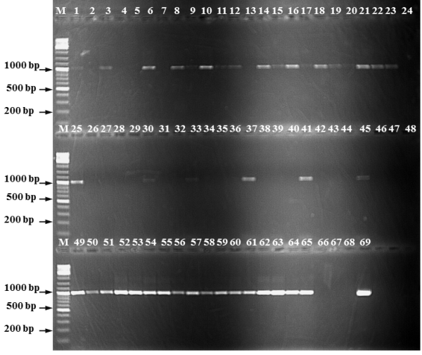
Figure 2: Detection of Pseudocercospora fijiensis using DNA extracted directly from infected leaves and using ITS species specific primers MF137/R635. Lane M is a 1000 bp DNA ladder,Lanes 1-67 contains DNA from infected leaf tissues; Lane 68 is negative control (No genomic DNA) and Lane 69 contain DNA from pure P. fijiensis isolate (positive control)

Catalogue distribution and impact of pest and pathogens for different banana varieties across different environments of Tanzania and Uganda

Disease severity of Sigatoka leaf spots in Uganda and Tanzania ranged from 3-55%, and this data is being used to associate sigatoka severity with altitude. Out of 920 samples collected from the surveys and on station in Kawanda 428 (46%) tested positive for P. fijiensis. Identification of other species will be done once a discriminatory set of primers is developed. A total of 40 pure isolates of P. fijiensis have been established from isolates collected from Sendusu and Kawanda. These isolates have been assigned to mating types using mating type specific primers. Of the 36 isolates that have been typed, 16 belong to mating type 1 while 20 belong to mating type 2. Isolations to get pure isolates of sigatoka pathogens for Arusha, Mbeya, Kagera and Mbarara are on-going. Once isolations have been finished, genetic characterization will be conducted using SSR markers.

Characterise species and populations of target pests and diseases recovered from visits to screening trials on station and at regional testing sites using morphological and molecular diagnostics and pathogenicity/virulence tests

During the visit to Mbeya, Kilimanjaro and Kawanda in April, 100 leaf samples were collected for Sigatoka species identification and characterization. Twenty pure culture isolates from Kawanda NARITA site have successfully been isolated and are growing on media for further characterization. PCR analysis using DNA extracted directly from infected leaves is on-going.

2.1.2: Collect and preserve Fusarium wilt, Sigatoka, nematodes and weevils from each breeding and testing site for characterization and rapid screening of bananas

40 P. fijiensis pure isolates were established; and the isolates characterized for mating type using mating-type specific primers and these have been put under long-term storage in glycerol stock at -80⁰c in IITA Pathology lab in Kawanda. Isolations from other sites is in progress.

2.1.3: Rapid and accurate methods to determine the identity and fitness of Fusarium wilt, Sigatoka, nematodes and weevils developed and validated
Published P. fijiensis specific primers are working well and these have been used to assay all samples collected for this pathogen. However, amplifications using published primers for other species associated with sigatoka have not been successfully. Because of the lack of positive controls, it was not possible to troubleshoot and determine the causes for this lack of amplification. We now have positive controls and this will continue.

2.1.4: Map the distribution of Fusarium wilt, Sigatoka, nematodes and weevils of banana and using GIS link to climatic and environmental data

Geo-referenced information for P. fijiensis has been completed and maps are being generated for this pathogen. Mapping of other sigatoka leaf spots will commence when the issues with PCR amplification failure have been addressed and all samples have been analyzed.

Intermediate outcome 2.2: Screen selected EAHB hybrids, Mchare diploids and NARITA hybrids for resistance to Fusarium wilt, Sigatoka, nematodes and weevils and determine influence of plant development, environmental conditions and season on disease severity

2.2.1. Map natural populations of Fusarium wilt, Sigatoka, nematodes and weevils on station and at regional field testing sites in Uganda and Tanzania and determine influence of plant development, environmental conditions and season on disease severity

Visits to the regional testing sites have begun to evaluate response of NARITA hybrids to natural populations of sigatoka pathogens and collect samples of diseases leaves to identify the species associated with the diseases. This has been done in Mbeya, Kawanda, and Kilimanjaro. Visits to Bukoba and Mbarara are scheduled for May.

2.2.2. Evaluate resistance of EAHB hybrids on station and determine influence of plant development, environmental conditions and season on disease severity caused by Fusarium wilt, Sigatoka, nematodes and weevils

The fourth evaluation of 26 NARITA hybrids for their response to Sigatoka diseases was conducted in Sendusu. Evaluation was done by recording the number of standing leaves, stage of infection/severity of disease and the youngest leaf spotted. Disease severity was assessed on a 0-6 severity scale (Gauhl et al., 1997). EAHB hybrids exhibit varying levels of susceptibility with DSI of 13-44% to disease. NARITA 16, 2, 20 and 26 were ranked among the tolerant based on disease severity index while NARITA 4, 24, 1 and 10 were the most susceptible. Lesions at different Foure stages (1-6) were observed but progression to mature lesions was not observed for some accessions (Figure 3).

Figure 3: Sigatoka severity index computed based on severity per leaf as described (Gauhl et al., 1997)

2.2.3. Evaluate resistance of selected Mchare diploids on station and determine influence of plant development, environmental conditions and season on disease severity caused by Fusarium wilt, Sigatoka, nematodes and weevils

Existing trial with 8 Mchare cultivars, (Kahuti, Muraru, Mchare, Mlelembo, Kamunyila, Nshonowa, Njuru and Huti shamba) in Kawanda have been evaluated three times that spanned different seasons. No significant differences were observed in disease severity indices on Mchares (P>0.05). The DSI values range from 42 % (Kahuti)-61% (Muraru) with symptoms progressing to stage 6.

2.2.4. Evaluate resistance of 27 NARITA hybrids under varied field conditions at 3 regional field test sites and determine influence of plant development, environmental conditions and season on disease severity caused by Fusarium wilt, Sigatoka, nematodes and weevils

Data on NARITA hybrids is currently being collected at five screening sites in Tanzania and Uganda. Preliminary results from an existing trial in Sendusu indicate that the NARITA exhibit different levels of susceptibility to Sigatoka disease as shown in fig 3. Evaluation in the regional testing sites is on-going to determine if response of NARITA is influenced by environment.

Intermediate outcome 2.3: Rapid and precise screening methods for Fusarium wilt, Sigatoka, nematodes and weevils developed for use in breeding programs

2.3.1. In vitro screening methods for Fusarium wilt, Sigatoka, nematodes and weevils developed to increase the speed and number of samples that can be evaluated in breeding programs

Test suitability of in vitro methods across target pests and pathogens for at least 10 selected banana varieties
To validate suitability of early screening methods, 25 banana genotypes including differential cultivars, parents used in development of mapping population and breeders materials have been established in a field trial in Sendusu (Table 4). Plants for screen house inoculations are under tissue culture multiplication. The trial will be used for studying components of resistance as well as validating rapid screening method.

Table 4: Banana varieties for Sigatoka resistance screening and protocol validation

Genotype | Ploidy | Genome group | ITC # | Reaction to Sigatoka
Yangambi KM5 | 3X | AAA | 1123 | Hypersensitive reaction
Calcutta 4 | 2X | AA | 0249 | Resistant-Stage 2
Pisang Lilin | 2x | AA | 1121 | Partially resistant- Stage 3
609 Pahang | 2x | AA | 0609 | Partially resistant-Stage 3
Williams | 3X | AAA | 0654 | Susceptible
0074 Malaccensis | 2x | AA | 0074 | Partially resistant-Stage 3
Cultivar Rose |  | AA | 0712 | Partially resistant-Stage 4
Mbwazirume | 3X | AAA | 0084 | Local check - susceptible
SH3362 | 2x | AA |  | Breeders' material
SH3217 | 2x | AA |  | Breeders' material
TMB2X9128-3 | 2x |  |  | Breeders' material
TMB2X5265-1 | 2x |  |  | Breeders' material
1438k-1 | 4X | AAAA |  | Breeders' material
10969S-1 | 2X | AA |  | Breeders' material
ZEBRINA GF | 2x | AA | 0966 | Mapping population parent
02145/1320 | 2x | AA |  | Breeders' material
222K-1 | 4X | AAAA |  | Breeders' material
376K-7 | 4X | AAAA |  | Breeders' material
Borneo | 2X | AA | 0253 | Mapping population parent
Kasaska | 2X | AA | 0591 | Mapping population parent
Kokopo | 2X | AA | 1243 | Mapping population parent
Mchare laini | 2X | AA |  | Mapping population parent
Mwitu pemba | 2X | AA |  | Mapping population parent
6142-1-S (Long Tavoy) | 2X | AA | 0093 | Mapping population parent
Monyet | 2X | AA | 1179 | Mapping population parent
Enzirabahima and Enyeru | 3x | AAA |  | EAHB(Border rows)

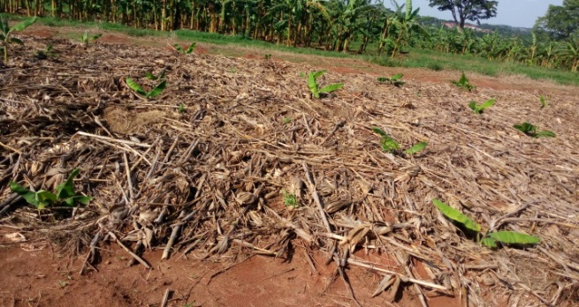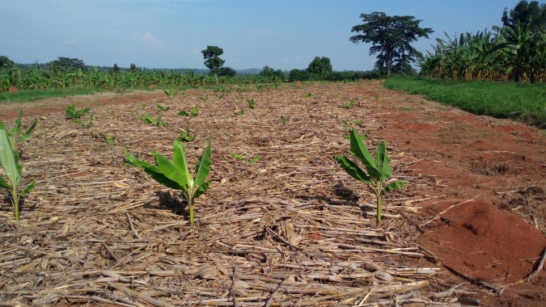
Figure 4: Field planted with selected genotypes for study of components of partial resistance and protocol validation

Eight differential cultivars in table 4 will be used for virulence testing of selected isolates of Sigatoka populations from Uganda and Tanzania.

2.3.2. Compare the reliability of young plant resistance testing to whole plant testing in field for evaluation against Fusarium wilt, Sigatoka, nematodes and weevils

A field trial has been established at Sendusu (Figure 4) and this will be used to validate results from rapid screening protocol.

Intermediate outcome 2.4: Train staff in banana disease evaluation, resistance screening and pathogen and pest identification with focus on Fusarium wilt, Sigatoka, nematodes and weevils

A joint training with WP4 was held in Kampala on 19-23rd September 2016. The site managers from the five NARITA experimental sites and field evaluators were trained on Sigatoka disease identification, field evaluation and data recording. A training manual was developed and distributed during the training which will be used as reference (Figure 5).
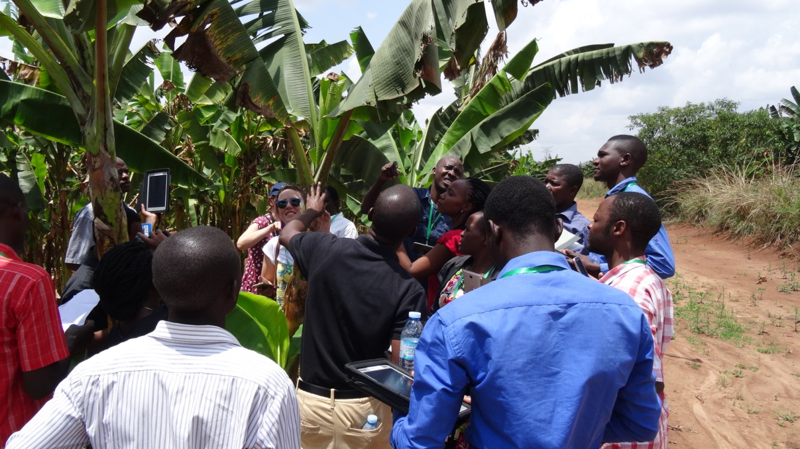
Figure 5: Training enumerators on collecting sigatoka data and harmonize disease screening protocols.

A training manual was developed for field diagnosis and evaluation of Sigatoka and other pest and diseases, sample collection and trial evaluations. This manual has been published as a book.

Training on Pseudocercospora isolation in Arusha
Isolation of the pathogen has been a major challenge in the study. A one week training to gain hands on experience in pathogen isolation was organized in IITA Arusha at the Nelson Mandela Institute of Agriculture and Technology (Figure 6). The training was facilitated by Dr. Amos Alakonya (IITA Banana Pathologist) on 26th Sept-1st October 2016.
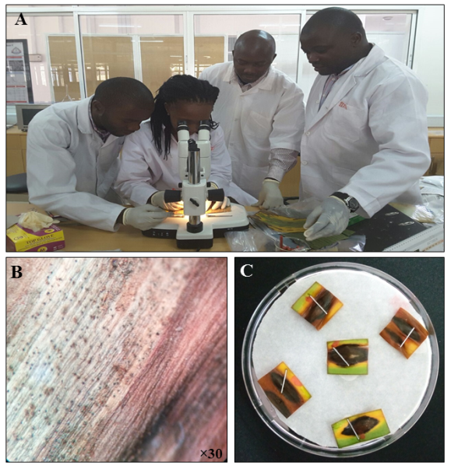
Figure 6: During the training session the participant L-R Evans Were (IITA Kawanda), Janet Njeri (PhD Student) and Kennedy Jomanga (IITA-Arusha) being guided by Amos Alakonya. A) Amos guide participants on how to locate lesions on banana leaves with intact pseudothecia under the stereo microscope for isolation Pseudocercospora spp. B) each participant clearly identified such lesions and C) the lesions were clearly marked out and carefully excised from the leaf samples.

REFERENCES

Gauhl, F. 1994. Epidemiology and Ecology of black Sigatoka (Mycosphaerella fijiensis Morelet) on Plantain and Banana (Musa spp.) in Costa Rica, Central America. INIBAP, Montpellier, France.

CHALLENGES ENCOUNTERED
- Establishment of experiments to develop a rapid screening protocol for response to Sigatoka was delayed because the company tasked with multiplying plants under tissue culture lost all plants a month before planting. As a backup, we used suckers to establish the trial.
- Activities to identify incidence and distribution of P.eumusae and P.musae were delayed. The reported primers did not amplify as expected and the lack of pure isolates to use as positive controls precluded us from trouble shooting. We have ordered pure cultures of all Pseudocercospora species from the CBS fungal collection and this work should progress rapidly. In addition, we will be able to design and optimize primers.
- Establishing pure cultures of Pseudocercospora spp. has been a major challenge. This is because the fungus grows very slowly and is outcompeted by saprophytes. Also, the fungus does not store very well on necrotic banana tissues thus isolations need to be conducted as soon as possible after collection for successful isolations. Using this, we have been able to establish cultures and this work should progress relatively fast, as the isolation protocol has been optimized.

LESSONS LEARNT
Given the prolonged delay in obtaining tissue culture plants and the slow growth of fungus in culture, proper planning is required to ensure timely delivery of expected outputs. It is good to have a backup plan, should things not go as planned.

WORK PLAN
- Finish the identification and characterisation of Pseudocercospora species and genetically characterise the isolates
- Determine pathogenic variability among genetically different isolates and implication in breeding
- Optimize inoculation protocol and develop a rapid screening protocol

