WORK PACKAGE 1 TECHNICAL REPORT FOR THE PROJECT “IMPROVEMENT OF BANANA FOR SMALLHOLDER FARMERS IN THE GREAT LAKES REGION OF AFRICA”

REPORTING PERIOD: 01 OCTOBER 2016 – 31 MARCH 2017

1 Executive Summary

This report presents the results of progress made by Work Package 1 (WP1) in 2.5 years (1 October 2015 to 31 MARCH 2017) of implementation of a 5-year project entitled “Improvement of Banana for Smallholder Farmers in the Great Lakes Region of Africa”. WP1 is aimed at increased Matooke and Mchare breeding pipeline performance by a 15-20%, higher production of seeds facilitating larger progeny populations from which to select better performing and more pest and disease resistant hybrids. Its key achievements for the last 2.5 years are 5825 hybrids from 4x-2x crosses, 3461 hybrids from 2x-2x crosses, 173 hybrids from 3x-2x crosses and 185 hybrids from Mchare-2x crosses in early evaluation trials, and 48 hybrid selections to be advanced to the preliminary yield trials. There are over 1000 seedlings in screen houses at IITA and NARO generated across all ploidy levels that are being planted in early evaluation trials. More seeds are being generated across ploidy levels. Research on floral biology and cross-ability in Matooke and Mchare is in progress and has so far shown that use of sucrose solution in pollination increases seed set by 108% compared to the conventional pollination technique. Prospects for success of this project with these studies and products are high.

Table of Contents
1 Executive Summary 1
Table of Contents 2
2 Primary Outcomes, Intermediate Outcomes, Outputs and Milestones 2
3 Results to Date 7
4 Challenges Encountered 9
5 Lessons Learned 9
7 Budget Summary 9
8 Other Relevant Project Information 10
ANNEX 1: Preliminary data on pollen quantity and bunch yield of some diploids in a trial at NARL 10
ANNEX 2: Banana genotypes selected from the first project early evaluation trial established in September 2015 11
ANNEX 3: Studies on pollen quantity and quality for some of the commonly used males at IITA-Arusha 13
ANNEX 4: Banana fields cleared by the Uganda Electricity Distribution Company Ltd during the construction of the electricity power line 14

2 Primary Outcomes, Intermediate Outcomes, Outputs and Milestones
Table 1 below provides information on the primary outcome, intermediate outcomes, outputs and milestones/targets for WP1 where NARO is the lead partner.

Table 1: Framework and results tracker for a work package 1 where NARO is the lead partner
 | Primary Outcome |  | Intermediate Outcomes |  | Outputs | Targets/ Milestones
 |  |  |  |  |  | YEAR 1 | YEAR 2 | YEAR 3 | YEAR 4 | YEAR 5
1 | Matooke and Mchare breeding pipeline performance increased by a 15-20% higher production of seeds facilitating larger progeny populations from which to select better performing and more pest and disease resistant hybrids | 1.1 | Profile of female fertile cultivars widened in Matooke and Mchare bananas: from 14 to 37 cultivars | 1.1.1 | Floral development stages at and after anthesis characterized in 2 Matoke varieties | "Inventory of seed set in Matoke varieties and selection of 2 Matoke varieties that are already field planted  Floral development stages in 2 Matoke varieties identified and characterized  Pictorial catalogue on flower developmental initiated" | "Characterisation of floral development stages of 2 Matoke varieties (weekly basis)  Pictorial catalogue on flower developmental finalized  Microscopy: stigma development and pollen tube growth correlated with flower developmental stages" | "Floral development stages of 2 Matoke varieties characterised at the moment of pollination (daily basis)  Microscopy: stigma development and pollen tube growth correlated with flower developmental stages (weekly basis)" | "Floral development stages of 2 Matoke varieties characterised at pollination (daily basis)" | NA
 |  |  |  | 1.1.2 | Floral development stage at pollination required to obtain maximum seed set and germination determined in 2 Matoke varieties . | NA | Preliminary correlation between seed set and flower and stigma developmental stages | Increased seed set of 10% correlated to specific flower and stigma developmental stages | Increased seed set of 20% correlated to a specific flower and stigma developmental stage and correlation with the seasonal - varietal effects | Seed germination correlated with bunch maturity and season
 |  |  |  | 1.1.3 | Floral development stages at and after anthesis characterized in 2 Mchare varieties | "Inventory of seed set in Mchare varieties and selection of 2 varieties for in vitro multiplication and field planting  Floral development stages in Mchare in the field collection identified/characterised" | "Characterisation of floral development stages of 2 Mchare varieties (weekly basis)  Pictorial catalogue on flower developmental stages initiated" | "Characterisation of floral development stages of 2 Mchare varieties (weekly basis)  Pictorial catalogue on flower developmental finalized  Microscopy started on stigma development and pollen tube growth with simultaneous flower characterisation" | "Characterisation of floral development stages of 2 Mchare varieties (at pollination)  Completion of microscopic study on stigma development and pollen tube growth with simultaneous flower characterisation" | "Characterisation of floral development stages of 2 Mchare varieties (at pollination)  Comparison of Matooke and Mchare flower/stigma/ developmental stages"
 |  |  |  | 1.1.4 | Floral development stage at pollination required to obtain maximum seed set determined in 2 Mchare varieties | NA | Preliminary correlation between seed set and flower and stigma developmental stages | "Seed set correlated to specific flower and stigma developmental stages" | Seed set correlated to a specific flower and stigma developmental stage and correlation with the seasonal - varietal effects | Seed germination correlated with bunch maturity and season
 |  | 1.2 | 70 diploid hybrids selected with enhanced disease and pest resistance, higher yield and good quality traits | 1.2.1 | At least 60 diploids of the NARO/IITA breeding program catalogued and characterised for pollen fertility, disease and pest resistance, high yield and quality traits | "At least 60 (improved) diploids multiplied in vitro and established for field characterisation in at least 2 locations  preparation of list of descriptors" | Progressive characterisation of at least 60 (improved ) diploids for pollen fertility, pest and disease response and agronomic performance | Final characterisation of at least 60 (improved ) diploids for pollen fertility, pest and disease response and agronomic performance and in addition a new set of 20 imported improved diploids for characterisation | Progressive characterisation of at least 20 improved diploids for pollen fertility, pest and disease response and agronomic performance | Progressive characterisation of at least 20 improved diploids for pollen fertility, pest and disease response and agronomic performance
 |  |  |  | 1.2.2 | At least 20 improved diploids from the EMBRAPA and NRCB breeding progams introduced to the NARO/IITA breeding program, characterised for pollen fertility, disease and pest resistance, high yields and quality traits | "At least 20 parthenocarpic diploids identified at EMBRAPA and NRCB, indexed and sent to NARO/IITA.  In vitro multiplication started at NARO/IITA" | "In vitro multiplication and field establishment of at least 20 improved parthenocarpic diploids from EMBRAPA and NRCB" | Progressive characterisation of at least 20 improved parthenocarpic diploids from EMBRAPA and NRCB for pollen fertility, pest and disease response and agronomic performance | "Complete characterisation (catalogue) of  at least 20 improved parthenocarpic diploids from EMBRAPA and NRCB for pollen fertility, pest and disease response and agronomic performance  First crosses performed with these 20 diploids as male parents" | 10 introduced improved diploids integrated in the Matooke and Mchare breeding programme and multiplied for large scale use
 |  |  |  | 1.2.3 | At least 50 diploid hybrids generated and selected for pollen fertility, disease and pest resistance, high yield and quality traits | "At least 40 wild and improved diploids planted in a crossing block for diploid improvement  At least 100 diploids generated from 3x x 2x crosses" | Generation, selection and characterisation of 2000 diploid hybrids from inter-diploid and inter-polyploid crosses | Generation, selection and characterisation of 4000 (cumulative) diploid hybrids from inter-diploid and inter-polyploid crosses | Generation, selection and characterisation of 6000 (cumulative) diploid hybrids from inter-diploid and inter-polyploid crosses | Generation, selection and characterisation of 8000 (cumulative) diploid hybrids from inter-diploid and inter-polyploid crosses
 |  | 1.3 | 95 Matoke hybrids with resistance to pest and diseases, 20-40% higher yield and enhanced consumer acceptability tested | 1.3.1 | 12,000 Matoke hybrids generated | "At least 10 Matoke varieties and 5 Matoke tetraploids established in large pollination blocks for 4X-2X and 3X-2X crosses  At least 4 other Matooke and 5 tetraploid Matooke multiplied for later crossing" | "At least 14 Matoke varieties and 10 Matoke tetraploids established in large pollination blocks for 4X-2X and 3X-2X crosses  Progressive generation of 3000 new Matoke hybrids" | "At least 14 Matoke varieties and 10 Matoke tetraploids established in large pollination blocks for 4X-2X and 3X-2X crosses  Progressive generation of 6000 (cumulative) new Matoke hybrids" | "At least 14 Matoke varieties and 10 Matoke tetraploids established in large pollination blocks for 4X-2X and 3X-2X crosses  Progressive generation of 9000 (cumulative) new Matoke hybrids" | "At least 14 Matoke varieties and 10 Matoke tetraploids established in large pollination blocks for 4X-2X and 3X-2X crosses  Progressive generation of 12000 (cumulative) new Matoke hybrids"
 |  |  |  | 1.3.2 | At least 12,500 Matoke hybrids evaluated in Early Evaluation Trials (EET) for agronomic performance | Embryo rescue and production of 500 Matoke hybrids | Embryo rescue and production of 3500 Matoke hybrids | Embryo rescue and production of 6500 (cumulative) Matoke hybrids | Embryo rescue and production of 9500 (cumulative) Matoke hybrids | Embryo rescue and production of 12500 (cumulative) Matoke hybrids
 |  |  |  | 1.3.3 | 95 Matoke hybrids from EET evaluated for yield, pest and disease response and consumer acceptability in Preliminary Yield Trials (PYT) | NA | NA | Progressive evaluation of 35 Matoke hybrids selected from EET for yield and consumer acceptability in PYT | Progressive evaluation of 65 (cumulative) Matoke hybrids selected from EET for yield and consumer acceptability in PYT | Complete evaluation of 95 Matoke hybrids selected from EET for yield and consumer acceptability in PYT
 |  | 1.4 | 2,400 Mchare hybrids generated and chromosome doubled plants developed | 1.4.1 | Generation of Mchare hybrids from crosses with (improved) diploids: 2,400 Mchare seeds | At least 2 Mchare varieties selected, in vitro multiplied for the establishment of large pollination blocks | "Field planting of large pollination blocks  First pollination and production of Mchare seeds" | Progressive generation of 600 Mchare seeds | "Field evaluation of Mchare hybrids  Progressive generation of 1200 Mchare seeds" | "Field evaluation of Mchare hybrids  Progressive generation of 2400 (cumulative) seeds"
 |  |  |  | 1.4.2 | Generation of 200 chromosome-doubled Mchare hybrids | "At least 2 Mchare varieties planted as a source of explants for chromosome doubling (see output 11)  chromosome doubling initiated"
 |  |  |  | 1.4.3 | Generation of Mchare hybrids with chromosome doubled Mchare plants: 200 seeds | NA | NA | 100 chromosome doubled lines crossed with improved diploids | "  Embryo rescue of doubled line crosses and in vitro regeneration  200 chromosome doubled lines crossed with improved diploids and selfed  " | "Field evaluation of hybrids  Embryo rescue of doubled line crosses and in vitro regeneration  200 chromosome doubled lines crossed with improved diploids and selfed  "
 |  |  |  | 1.4.4 | 2,400 Mchare hybrids evaluated in Early Evaluation Trials (EET) for agronomic performance | NA | NA | Early evaluation trial ( EET) with 600 hybrids | Early evaluation trial ( EET) with 1200 hybrids | Early evaluation trial ( EET) with 2400 hybrids

3 Results to Date

The results achieved by WP 1 during 1 October 2016 – 31 March 2017 are presented in Table 2

Table 2: Progress for work package 1 during 1 October 2016 – 31 March 2017
 | Outputs | Targets/ Milestones | Progress | Variance
 |  | YEAR 3
1.1.1 | Floral development stages at and after anthesis characterized in 2 Matoke varieties | "Floral development stages of 2 Matoke varieties characterised at the moment of pollination (daily basis)  Microscopy: stigma development and pollen tube growth correlated with flower developmental stages (weekly basis)" | A video footage of floral development in Enzirabahima and Nakitembe was compiled. Bracts of seed fertile banana varieties open earlier than seed sterile varieties which open later, flowers usually open in evening.  The process of accessing appropriate microscope for this work is underway thus the microscopy work is yet to be done | 100% achieved – 0% variance.  0% achieved– 100% variance to be achieved by October 2017
1.1.2 | Floral development stage at pollination required to obtain maximum seed set and germination determined in 2 Matoke varieties . | Increased seed set of 10% correlated to specific flower and stigma developmental stages | Field studies on Enzirabahima and Nakitembe flowers, especially on the patterns of seed set have shown that the stigma can be more receptive before flower opening and seed set occurs mostly in lower hands  The use of sucrose solution in pollination has also been shown to increase seed set by 108% compared to the conventional pollination technique. | 90 % achieved – 10 % variance expected to be achieved by October 2017.
1.1.3 | Floral development stages at and after anthesis characterized in 2 Mchare varieties | "Characterisation of floral development stages of 2 Mchare varieties (weekly basis)  Pictorial catalogue on flower developmental finalized  Microscopy started on stigma development and pollen tube growth with simultaneous flower characterisation" | A video footage of floral development in Mulelembo and Mshale cv. was compiled. Bracts of seed fertile banana varieties open earlier than seed sterile varieties which open later, flowers usually open in evening.  Pictorial data collection of floral development characteristic in Mulelembo and Mshale cv. Is ongoing.  The process of accessing appropriate microscope for this work is underway thus the microscopy work is yet to be done | 100% achieved – 0% variance.  60% achieved– 40% variance to be achieved by October 2017  0% achieved– 100% variance to be achieved by October 2017
1.1.4 | Floral development stage at pollination required to obtain maximum seed set determined in 2 Mchare varieties | "Seed set correlated to specific flower and stigma developmental stages" | Field studies on Mulelembo and Mshale cv flowers, especially on the patterns of seed set and the time stigmas are most receptive before flower opening. More observations are being made. | 60% achieved– 40% variance to be achieved by October 2017
1.2.1 | At least 60 diploids of the NARO/IITA breeding program catalogued and characterised for pollen fertility, disease and pest resistance, high yield and quality traits | Final characterisation of at least 60 (improved ) diploids for pollen fertility, pest and disease response and agronomic performance and in addition a new set of 20 imported improved diploids for characterisation | Data collection on agronomic, pest and disease resistance traits and pollen fertility on 30 diploids planted in progress. Partial data pollen quantity and yield of some diploids are shown in Annex 1. Collection of data continues for the next two ratoons. | 65% achieved- 35% variance to be achieved by March 2018.
1.2.2 | At least 20 improved diploids from the EMBRAPA and NRCB breeding progams introduced to the NARO/IITA breeding program, characterised for pollen fertility, disease and pest resistance, high yields and quality traits | Progressive characterisation of at least 20 improved parthenocarpic diploids from EMBRAPA and NRCB for pollen fertility, pest and disease response and agronomic performance | 20 parthonocarpic diploids received from EMBRAPA were multiplied invitro and have just been weaned. | 80% achieved- 20% variance to be achieved by September 2017 upon planting of characterization trials.
1.2.3 | At least 50 diploid hybrids generated and selected for pollen fertility, disease and pest resistance, high yield and quality traits | Generation, selection and characterisation of 4000 (cumulative) diploid hybrids from inter-diploid and inter-polyploid crosses | 3461 hybrids were generated from inter-diploid crosses are in EETs being evaluated for pollen quantity and quality. | 87% achieved- 13 % variance to be achieved through continued inter-diploid and inter-polyploid crosses.
1.3.1 | 12,000 Matoke hybrids generated | "At least 14 Matoke varieties and 10 Matoke tetraploids established in large pollination blocks for  4X-2X and 3X-2X crosses  Progressive generation of 6000 (cumulative) new Matoke hybrids" | 15 matooke varieties were planted in large pollination blocks (6.0 ha) at IITA-Sendusu and NARO-Kawanda. The matooke varieties planted are: Bitambi, Entukura, Enzirabahima, Nakyetengu, Kabucuragye, Kazirakwe, Nakabururu, Nakasabira, Nakawere, Nakayonga, Namande, Namwezi, Nfuuka, Rwambarara and Tereza.  10 matooke tetraploids were planted in large pollination blocks (1.0 ha) at NARO-Kawanda. The tetraploids planted are 917K-2, 660K-1, 222K-1, 401K-1, 376K-1, 1201K-1, 1411K-1, 199K-3, 1438k-1 & 365K-1  Preliminary analyses made for seed set in the above 15 matooke varieties have shown that most seeds are extracted from, Nakyetengu, Nakawere, Nakasabira, Enzirabahima, Nakabururu. We suggest that these five matooke hybrids be focused on for further pollinations.  173 hybrids from 3x-2x crosses already planted in EETs.  -5825 hybrids from 4x-2x crosses already planted in EETs | 100% achieved.  100% achieved.  99.9% achieved – 0.1% variance to be achieved as more matooke hybrid seeds are being generated.
1.3.2 | At least 12,500 Matoke hybrids evaluated in Early Evaluation Trials (EET) for agronomic performance | Embryo rescue and production of 6500 (cumulative) Matoke hybrids | The cumulative number of matooke hybrid seeds produced over the past 2.5 years  3x -2x = 2396  4x - 2x = 149,265  The cumulative number of embryos cultured over the past 2.5 years:  3x -2x = 1281  4x - 2x = 101784 | 100% achieved.
1.3.3 | 95 Matoke hybrids from EET evaluated for yield, pest and disease response and consumer acceptability in Preliminary Yield Trials (PYT) | Progressive evaluation of 35 Matoke hybrids selected from EET for yield and consumer acceptability in PYT | 48 Matoke hybrids were selected from EET for PYT evaluation (details of 41 hybrids are shown in Annex 2) | 142% achieved.
1.4.1 | Generation of Mchare hybrids from crosses with (improved) diploids: 2,400 Mchare seeds | Progressive generation of 600 Mchare seeds | 185 hybrids from Mchare-2x are under evaluation EETs.  577 Seeds of Mchare were generated.  Studies on pollen quantity and quality for some of the commonly used males were done and are shown in  ANNEX 3. | 23 % achieved – 77% variance to be achieved by 2018.
1.4.2 | Generation of 200 chromosome-doubled Mchare hybrids |  | NA
1.4.3 | Generation of Mchare hybrids with chromosome doubled Mchare plants: 200 seeds | 100 chromosome doubled lines crossed with improved diploids | Chromosome doubling work for Mchare varieties at NARL has generated the following number of plants: Mlelembo=12, Hutishamba=4, Mshale=7, and Nshonowa=2 (These are yet to be planted in a pollination block). | 50% achieved- 50 variance to be achieved by March 2018
1.4.4 | 2,400 Mchare hybrids evaluated in Early Evaluation Trials (EET) for agronomic performance | Early evaluation trial ( EET) with 600 hybrids | Not yet done | 0% achieved-100% to be achieved by 2019.

4 Challenges Encountered
- NARL lost some of its pollination blocks and EETs by the Uganda Electricity Distribution Company Ltd (UEDCL). Through its ongoing exercise of construction of the electricity power lines to the neighboring countries of Rwanda and Burundi, UEDCL cleared some of the NARL banana pollination blocks and EETs that were under the proposed power lines. The affected blocks comprised of EAHBs, improved diploids and Mchare cultivars covering at least 2.0Ha (Annex 4). The EETs consisted of 4x-2x and 2x-2x crosses covering at least 0.5Ha (Annex 4). Interesting however, the construction of power lines at NARL is now complete and the affected plants are sprouting. Hopefully, within a period of five months all the affected fields will have recovered.

- Long periods of drought that affected the planting and harvesting of some experiments.

5 Lessons Learned
- Planting of more pollination blocks, especially for the more seed fertile parents.
- Putting in place alternative measures for irrigation/watering project trials to avoid the negative effects of extended droughts.

Generally, the overall work plan including timeline was not adjusted. In case the major revisions are thought needed in the general work plan and budget, they will be discussed with the project coordinator in the forthcoming annual project meeting in Uganda.

7 Budget Summary
The budget was made according to the original proposal, without any major adjustments or variances. The summarized and detailed financial reports will be provided by the Finance department of the respective WP1 partners (NARO & IITA).

8 Other Relevant Project Information
Work package 1 is making very good progress and moving smoothly as per plan.

ANNEXES

ANNEX 1: Preliminary data on pollen quantity and bunch yield of some diploids in a trial at NARL

Pollen quantity was assessed on a scale of 0-4 where; 0= no pollen, 1 = very little pollen, 2 = little pollen, 3= moderate pollen, 4 = abundant pollen.

Table 1: Pollen quantity and bunch yield of some diploids in a trial at NARL

Genotype | Pollen Quantity  Score on scale 1-4 | Bunch weight (kg)  (Kg)
02145/1320 | 1.0 ± 0.5 | 3.0 ± 1.2
1019 | 1.0 ± 0.3 | 2.0 ± 0.8
1119 | 2.7 ± 0.3 | 1.6 ± 0.5
1603 | 2.4 ± 0.2 | 1.4 ± 0.4
1702 | 2.6 ± 0.2 | 2.4 ± 0.4
201087-3 | 3.0 ± 0.8 | 2.0 ± 1.7
201087-4 | 2.0 ± 0.8 | 5.0 ± 1.7
2215 | 4.0 ± 0.5 | 2.5 ± 1.2
2216 | 2.8 ± 0.3 | 2.5 ± 0.7
2710 | 2.5 ± 0.3 | 3.3 ± 0.7
5265-1 | 1.4 ± 0.2 | 2.7 ± 0.5
7197-2 | 2.8 ± 0.3 | 6.1 ± 0.6
TMB2x8075-7 | 3.6 ± 0.2 | 3.8 ± 0.4
81k | 3.1 ± 0.2 | 2.7 ± 0.5
919 | 2.0 ± 0.8 | 3.0 ± 1.7
F1C4N | 2.6 ± 0.3 | 1.7 ± 0.6
UZAKAN | 1.0 ± 0.5 | 9.5 ± 1.2
Kasaska | 2.0 ± 0.8 | 1.0 ± 1.7
Khaithoungruang | 2.5 ± 0.4 | 2.8 ± 0.8
Makyungwe | 1.0 ± 0.4 | 7.8 ± 0.8
SH3142 | 2.0 ± 0.5 | 7.0 ± 1.2
TMB2x5105-1 | 2.2 ± 0.3 | 3.4 ± 0.8
TMB2x6142 | 2.0 ± 0.4 | 2.5 ± 0.8
TMB2x9172 | 2.0 ± 0.4 | 2.2 ± 0.8
TUU GIA | 1.2 ± 0.3 | 4.8 ± 0.8
Yalim | 1.0 ± 0.5 | 5.0 ± 1.2
Zebrina GF | 1.4 ± 0.3 | 2.2 ± 0.8
Calcut4 | 3.9 ± 0.3 | 2.4 ± 0.6
Mlelembo | 1.0 ± 0.5 | 9.0 ± 1.2
Mean | 2.6 ± 0.5 | 3.6 ±1 .4

ANNEX 2: Banana genotypes selected from the first project early evaluation trial established in September 2015

Table 2: Banana genotypes selected from the first project early evaluation trial established in September 2015
No. | Genotype Code | Cross | HT | GTH | NSL | YLS | HTTS | NoS | BWT | HDS | FL | FC | NF | NLH | DTM | Remark§
1 | 10/569-10 | 365K-1x402 | 240 | 39 | 7 | 5 | 140 | 8 | 9 | 7 | 9 | 6 | 98 | 0 |  | *
2 | 10/569-15 | 365K-1x402 | 195 | 38 | 10 | 9 | 160 | 6 | 8 | 6 | 12 | 11 | 86 | 0 | 184 | ****
3 | 10/574-3 | 199K-1x402 | 210 | 41 | 8 | 7 | 120 | 4 | 6 | 6 | 8 | 7 | 86 | 0 | 147 | ****
4 | 10/579-1 | 1411K-1x2905 | 195 | 36 | 9 | 9 | 150 | 4 | 14 | 7 | 14 | 9 | 96 | 4 | 196 | *****
5 | 10/579-2 | 1411K-1x2905 | 195 | 36 | 12 | 11 | 160 | 6 | 12 | 7 | 12 | 11 | 86 | 3 | 196 | ****
6 | 10/579-3 | 1411K-1x2905 | 200 | 36 | 13 | 11 | 195 | 4 | 10 | 6 | 12 | 11 | 90 | 2 | 196 | ****
7 | 10/579-4 | 1411K-1x2905 | 220 | 40 | 10 | 8 | 140 | 4 | 12 | 7 | 12 | 11 | 98 | 4 | 63 | *****
8 | 10/585-6 | 401K-1x402 | 245 | 45 | 11 | 8 | 140 | 3 | 20 | 8 | 15 | 13 | 123 | 2 | 164 | ****
9 | 10/585-7 | 401K-1x402 | 240 | 40 | 8 | 6 | 150 | 2 | 8 | 8 | 12 | 10 | 101 | 0 | 150 | *
10 | 10/585-8 | 401K-1x402 | 220 | 36 | 9 | 6 | 100 | 3 | 9 | 8 | 13 | 10 | 109 | 0 | 147 | ***
11 | 10/595-1 | 199K-3x402 | 230 | 32 | 9 | 7 | 190 | 2 | 8 | 6 | 13 | 11 | 98 | 0 | 138 | ****
12 | 10/601-2 | 1154K-1x402 | 210 | 35 | 12 | 9 | 30 | 1 | 14 | 9 | 16 | 11 | 125 | 3 | 133 | ****
13 | 10/601-5 | 1154K-1x402 | 204 | 36 | 11 | 9 | - | 0 | 12 | 6 | 13 | 13 | 89 | 2 | - | ****
14 | 10/601-7 | 1154K-1x402 | 210 | 49 | 8 | 7 | 150 | 7 | 10 | 6 | 14 | 11 | 98 | 0 | 175 | ****
15 | 10/669-24 | 1411K-1x402 | 200 | 40 | 12 | 10 | 170 | 8 | 5 | 4 | 10 | 10 | 48 | 0 | 175 | *****
16 | 10/669-38 | 1411K-1x402 | 210 | 39 | 14 | 8 | 160 | 5 | 10 | 8 | 13 | 11 | 88 | 2 | 168 | ****
17 | 10/669-5 | 1411K-1x402 | 210 | 43 | 15 | 10 | 160 | 9 | 11 | 7 | 13 | 11 | 108 | 1 | 175 | *
18 | 10/669-62 | 1411K-1x402 | 250 | 44 | 9 | 7 | 150 | 8 | 7 | 7 | 13 | 11 | 98 | 0 | 175 | **
19 | 10/669-83 | 1411K-1x402 | 210 | 39 | 9 | 5 | 140 | 7 | 6 | 7 | 11 | 10 | 89 | 2 | 164 | **
20 | 10/669-85 | 1411K-1x402 | 190 | 38 | 9 | 5 | 160 | 7 | 8 | 8 | 12 | 11 | 88 | 1 | 171 | **
21 | 10/671-5 | 376Kx402 | 210 | 33 | 8 | 5 | 145 | 4 | 8 | 6 | 13 | 10 | 66 | 0 | 182 | **
22 | 10/672-1 | 401Kx402 | 215 | 30 | 6 | 5 | 180 | 6 | 7 | 7 | 12 | 11 | 97 | 0 | 147 | ***
23 | 10/672-2 | 401Kx402 | - | - | - | - | - | 0 | 10 | 6 | 13 | 10 | 87 | 3 | - | ****
24 | 10/672-4 | 401Kx402 | 155 | 31 | 10 | 9 | 130 | 6 | 6 | 5 | 12 | 11 | 55 | 0 | 174 | *****
25 | 10/672-5 | 401Kx402 | 180 | 34 | 12 | 10 | 100 | 5 | 7 | 7 | 12 | 10 | 49 | 0 | 189 | ***
26 | 10/672-8 | 401Kx402 | 210 | 37 | 11 | 9 | 165 | 6 | 7 | 6 | 12 | 10 | 87 | 1 | 161 | ****
27 | 10/686-12 | 365Kx402 | 200 | 29 | 9 | 9 | 140 | 6 | 5 | 6 | 10 | 9 | 76 | 0 | 163 | ****
28 | 10/687-5 | 660K-1x716 | 220 | 30 | 8 | 6 | 180 | 4 | 5 | 5 | 14 | 10 | 108 | 0 | 147 | ***
29 | 10/689-5 | 660K-1x2905 | 175 | 40 | 15 | 13 | 135 | 3 | 7 | 4 | 14 | 11 | 54 | 1 | 161 | ***
30 | 10/689-7 | 660K-1x2905 | 195 | 39 | 9 | 9 | 150 | 6 | 6 | 4 | 13 | 10 | 51 | 1 | 196 | ***
31 | 10/700-10 | 660K-1x716 | 250 | 40 | 11 | 9 | 170 | 3 | 15 | 6 | 16 | 13 | 106 | 1 | 167 | ***
32 | 10/700-12 | 660K-1x716 | 155 | 30 | 11 | 11 | 10 | 1 | 6 | 5 | 13 | 10 | 60 | 0 | 140 | ***
33 | 10/700-14 | 660K-1x716 | 260 | 35 | 7 | 6 | 170 | 6 | 10 | 7 | 14 | 11 | 94 | 0 | 168 | ****
34 | 10/700-17 | 660K-1x716 | 152 | 38 | 13 | 9 | 130 | 4 | 6 | 5 | 11 | 11 | 54 | 1 | 147 | ***
35 | 10/700-18 | 660K-1x716 | 190 | 38 | 9 | 7 | 160 | 7 | 6 | 5 | 13 | 10 | 51 | 0 | 160 | **
36 | 10/700-20 | 660K-1x716 | - | - | - | - | - | 0 | 8 | 6 | 11 | 10 | 87 | 0 | - | ****
37 | 10/700-8 | 660K-1x716 | 240 | 40 | 11 | 9 | 200 | 6 | 8 | 6 | 13 | 11 | 103 | 0 | 154 | *****
38 | 10/702-2 | 199K-3x2905 | 200 | 39 | 12 | 12 | 150 | 6 | 12 | 6 | 14 | 11 | 91 | 0 | 182 | *
39 | 10/669-32 | 1411K-1x402 | 170 | 32 | 7 | 5 | 140 | 4 | 8 | 7 | 11 | 10 | 103 | 0 | 180 | ***
40 | 10/601-1 | 1154K-1x402 | 170 | 36 | 10 | 10 | 110 | 3 | 10 | 7 | 14 | 13 | 102 | 2 | 171 | ****
41 | 10/601-3 | 1154K-1x402 | 167 | 37 | 11 | 9 | 112 | 4 | 11 | 9 | 13 | 12 | 118 | 3 | 168 | ****
42 | Mbwazirume | N/A | 219.1 | 46.2 | 8.7 | 6.5 | 143.2 | 2.5 | 7.8 | 5.6 | 14.0 | 11.5 | 85.0 | 3.7 | 97.5 | **
Mean |  |  | 205.4 | 37.4 | 10.1 | 8.2 | 143.2 | 4.5 | 8.9 | 6.4 | 12.6 | 10.6 | 87.8 | 1.0 | 162.4
S.D |  |  | 27.0 | 4.5 | 2.2 | 2.1 | 37.3 | 2.3 | 3.1 | 1.2 | 1.6 | 1.3 | 20.5 | 1.3 | 26.1
CV (%) |  |  | 13.1 | 12.1 | 21.5 | 25.8 | 26.0 | 5.4 | 34.9 | 19.0 | 12.8 | 10.6 | 23.4 | 127.8 | 16.1
HT=Plant height (cm), GTH= plant girth (cm), NSL= number of green standing leaves, YLS= youngest leaf spotted at flowering, HTTS= height of tallest sucker at flowering, NoS= number of suckers, BWT= bunch weight (kg), HDS= number of hands, FL= fruit length, FC= fruit circumference, NF= number of finger/bunch, NLH= number of leaves at flowering, and DTM=days to bunch maturity.
Remark§= Defines the level of acceptance of the test genotypes in terms of pulp colour and sap content compared to Mbwazirume (a local check)
***** (5 stars) = No sap and deep yellow pulp colour same as that of Mbwazirume
**** (4 stars) = No sap and yellow pulp colour almost same as that of Mbwazirume
**** (3 stars) = No sap and yellow colour slightly lighter than that of Mbwazirume
** (2 stars) = With little sap and colour slightly lighter than that of Mbwazirume
* (1 star) = With a lot of sap and white colour

ANNEX 3: Studies on pollen quantity and quality for some of the commonly used males at IITA-Arusha

POLLEN VIABILITY VARIABILITY AMONG EAST AFRICAN DIPLOIDS
- Quantity of pollen grains per cultivar

 |  | Quantity |  |  |  | SD
 | Cultivar | slide 1 | slide 2 | slide 3 | average
Males | C4 | 34250 | 33907 | 32494 | 33550 | 930.5
 | Pisang Pahang | 32124 | 31107 | 32190 | 31807 | 607.1
 | CV rose | 29367 | 28907 | 29345 | 29206 | 259.5
 | Trucanta | 25781 | 25721 | 24980 | 25494 | 446.1
 | Zebrina GF | 8930 | 8720 | 8447 | 8699 | 242.2
 | Borneo | 25784 | 36123 | 36430 | 32779 | 6059.8
Mchare | Huti white | 5920 | 5790 | 5810 | 5840 | 70
 | Huti green | 4324 | 3912 | 4398 | 4211 | 261.9
 | Mshare laini | 5265 | 4876 | 4997 | 5046 | 199.2
 | Mchale mlelembo | 2757 | 2858 | 2412 | 2675 | 233.9
 | Akondro mainty | 3260 | 3178 | 2645 | 3028 | 333.9
 | Makyugu I | 0 | 0 | 0 | 0
 | Ijihu inkundu | 0 | 0 | 0 | 0

- Viability percentage

 | Cultivar | Viability (%)
 |  | slide 1 |  | slide 2 |  | slide 3 |  | Average | SD
Males | C4 | 76.4 | 80.1 | 84.3 | 80.4 | 78.6 | 76.6 | 79.4 | 4.6
 | Pisang Pahang | 67.3 | 80.1 | 80.9 | 74.3 | 78.6 | 70.6 | 75.3 | 5.
 | CV rose | 56.7 | 56.4 | 50.1 | 52.6 | 52 | 46.7 | 52.4 | 3.8
 | Trucanta | 68.9 | 67 | 82.6 | 64.6 | 72 | 74.3 | 71.5 | 5.8
 | Zebrina GF | 31.6 | 18.8 | 23.6 | 20 | 27 | 22.6 | 23.9 | 4.3
 | Borneo | 83 | 68.9 | 78.6 | 76.4 | 81.6 | 84.8 | 78.9 | 5.2
Mchare | Huti white | 68.3 | 56.7 | 65.8 | 67.9 | 70.7 | 76.4 | 67.6 | 5.9
 | Huti green | 28.6 | 25.3 | 38.5 | 30.2 | 43 | 46.3 | 35.35 | 7.8
 | Mshare laini | 53 | 48.3 | 46.7 | 48.4 | 66 | 62.4 | 54.13 | 7.4
 | Mchale mlelembo | 46.7 | 32.8 | 36.4 | 35.6 | 41.6 | 44.6 | 39.6 | 5
 | Akondro mainty | 12.6 | 18.7 | 31.3 | 34.3 | 28.9 | 27.3 | 25.5 | 9.5
 | Makyugu I |  | 0 | 0 | 0 | 0 | 0 | 0 | 0
 | Ijihu inkundu |  | 0 | 0 | 0 | 0 | 0 | 0 | 0

ANNEX 4: Banana fields cleared by the Uganda Electricity Distribution Company Ltd during the construction of the electricity power line
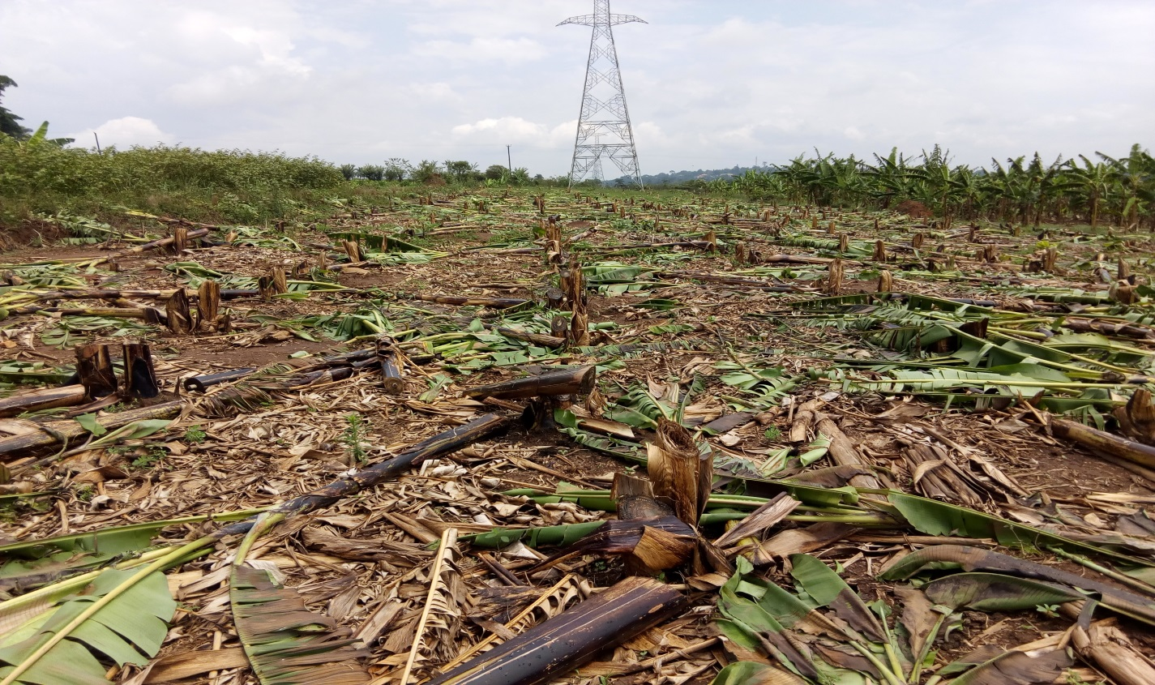
Figure 1: A pollination block of EAHBs and Mchare cultivars cleared of its plants

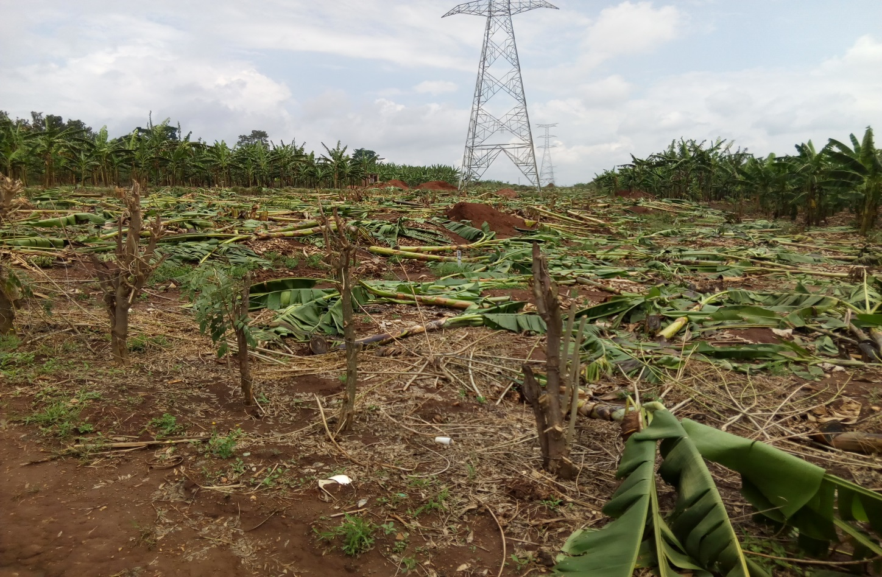
Figure 2: A pollination block of the improved diploids and part of the EET cleared of their plants

