Annual Progress Report of ICAR-NRCB

AG-4419

Project entitled
Accelerated Breeding of Better Bananas’

Reporting Period: 1st October 2019 – 30th September 2020

ICAR -National Research Centre for Banana
Thogamalai Road, Thayanur post, Tiruchirappalli – 620102 Tamil Nadu, India.

Progress Narrative
General Progress
- A total of nine tetraploids were obtained when embryogenic cell suspension of Neypoovan (AB) was treated with antimitotic agent Oryzalin. Its ploid was confirmed through Flow cytometer. Of this, three tetraploids are in flowering stage and are highly pollineferous in nature. The side suckers are being multiplied for large scale evaluation of the promising tetraploids. (Fig.1).
- Pisang Awak hybrids are being multiplied for large scale evaluation under hot spot area of Foc race 1 and race 4.
- Two batches of IITA hybrids have been received but with unforeseen transit delays, of which six accessions of first batch hybrids were planted under hot spot area for Foc race 1 screening and are in flowering stage (Table 1 & Fig. 2.).
- In the second batch of IITA hybrids, 10 NARITA hybrids, seven PITA hybrids and two other hybrids, with a total of nineteen hybrids were established in tissue culture. Among them seven are field planted in the month of October and the remaining are in various stages of multiplication. After hardening they will be evaluated for yield and Foc resistance under hot spot area of Foc race1 and TR 4 (Table 2a & 2b).
- Among the field planted IITA hybrids OSH No. 75 was found to exhibit higher yield, with the bunch weight of 21 kilograms followed by OSH No. 146, 53, 10 and 1 (Table 2c).
- The tissue culture propagules of four improved diploids of ICAR-NRCB are ready for sharing and the export will be done after getting the approval of phase II (sub grant agreement with IITA) which is awaiting clearance from Ministry of Agriculture and Farmers Welfare.

Key Deliverable Deviation
- Export of ICAR-NRCB is delayed (as Phase I is completed and Phase II is yet to take of officially) due to getting approval from ICAR-HQ, New Delhi.
- The main reason for delay in getting approval is because of change in the sponsoring agents from Bioversity (sub contract to NRCB) to IITA. Thus it requires many formalities like signing separate MoU with ICAR and IITA as per the guidance issued by Ministry of Agriculture and Farmers Welfare, Govt. of India.
Plans for Next Reporting Period
- Mass multiplication of the second batch of remaining IITA hybrids will be continued and kept ready for field planting at hot spot areas
- ICAR-NRCB developed improved diploids and other progenies (11) will be evaluated at TR4 hot spot area
- First batch of remaining IITA hybrids will be planted under hot spot area against Foc TR 4
- Characterization of first batch of IITA hybrids for yield parameters will be taken up.
- ICAR-NRCB developed tetraploids under field evaluation will be characterized at flowering stage.
- Multiplication of hybrids will be continued , upon receipt of the 3rd batch of IITA hybrids,
Risks
- Getting approval from ICAR Head quarters is getting delayed owing to COVID-19 pandemic lockdown.
- Man Power of BBB 1 project are still maintained for smooth progress of the project and salary will be given after signing of the sub grant agreement with IITA.
Sustainability : Too early to report
Scalability : Too early to report
Lessons Learned : Too early to report
Financial Reporting : Funds not received yet due to delay in signing MoU from our HQ.
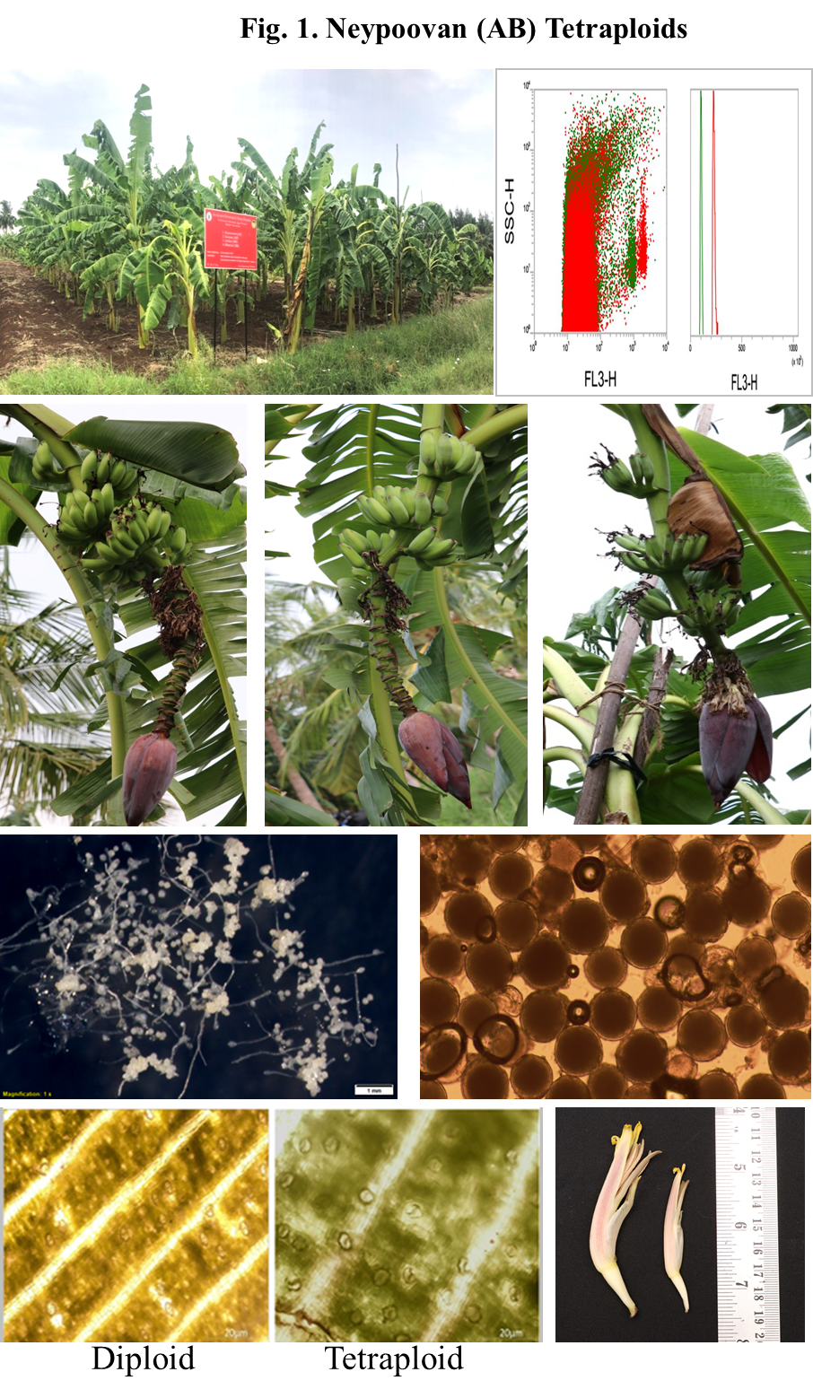
Table 1. IITA Accession - I Batch
S.No. | IITA No | OSH No | Ploidy | In vitro maintenance | Field planted
1 | TMPX1 | 1 | 4x | - | 5
2 | TMPX3 | 3 | 4x | - | -
3 | TMPX24 | 27 | 4x | - | -
4 | TMPX29 | 32 | 4x | - | -
5 | TMPX36 | 41 | 4x | - | -
6 | TMPX40 | 45 | 4x | - | -
7 | TMPX61 | 75 | 3x | - | 4
8 | TMPX69 | 84 | 3x | - | -
9 | TMPX76 | 91 | 3x | - | -
10 | TMPX123 | 142 | 3x | - | -
11 | TMPX124 | 143 | 3x | - | -
12 | TMPX129 | 150 | 3x | - | -
13 | TMPX146 | 176 | 3x | - | -
14 | TMPX133 | 154 | 3x | - | -
15 | TMBX8 | 53 | 2x | - | 8
16 | TMPX9 | 10 | 2x | - | 3
17 | TMBX10 | 57 | 2x | - | -
18 | TMPX10 | 12 | 2x | - | -
19 | TMPX26 | 29 | 2x | - | -
20 | TMPX117 | 36 | 2x | - | -
21 | TMPX127 | 146 | 2x | - | 5
Totally 21 accession were received from IITA; among 21 accession, only 5 were survived in field
Table 2a. IITA Accessions - II Batch
S.No. | IITA No | Ploidy | No. of bottles  in vitro | No of plants in in hardening | Field plant
1 | TMPX3 | 4x | 1 | 4 | -
2 | TMPX24 (PITA 5) | 4x | 1 | 2 | -
3 | TMPX 29 (PITA 17) | 4x | 3 | 3 | -
4 | TMPX36 | 4x | - | - | -
5 | TMPX69 | 3x | 3 | 15 | 1
6 | TMPX123 (PITA 23) | 3x | 2 | 7 | -
7 | TMPX124 (PITA 24) | 3x | 2 | 2 | -
8 | TMPX129 | 3x | 3 | - | -
9 | TMPX133 | 3x | - | - | -
10 | PITA-22 | 3x | Not received | - | -
11 | TMPX10 | 2x | 2 | 6 | 4
12 | TMPX26 | 2x | 3 | 6 | 1
13 | TMPX117 | 2x | - | - | 4

Table 2b. IITA Accessions - II Batch
S.No. | IITA No | No of bottles in vitro maintenance | No of plants in hardening | Field plant
1 | NARITA -3 | - | - | -
2 | NARITA-4 | - | - | -
3 | NARITA-7 | - | - | -
4 | NARITA-8 | 5 | 9 | 4
5 | NARITA-10 | - | 1 | -
6 | NARITA-11 | - | - | -
7 | NARITA-12 | 2 | 13 | 4
8 | NARITA-14 | - | 10 | -
9 | NARITA-17 | 4 | - | -
10 | NARITA-18 | 1 | 2 | -
11 | NARITA-21 | 3 | 7 | 1
12 | NARITA-22 | - | - | -
13 | NARITA-23 | 4 | 8 | -
14 | NARITA-24 | 2 | - | -

Table 2c. Yield Characteristics of IITA hybrids
S. No. | Name of IITA accessions | Bunch weight | Total number of hands | Total number of fruits | Number of fruits in 2nd hand
1 | OSH No. 1 | 12 | 6 | 74 | 13
2 | OSH No. 10 | 14 | 8 | 92 | 14
3 | OSH No. 53 | 16 | 8 | 98 | 15
4 | OSH No. 75 | 21 | 10 | 124 | 15
5 | OSH No. 146 | 18 | 9 | 112 | 14

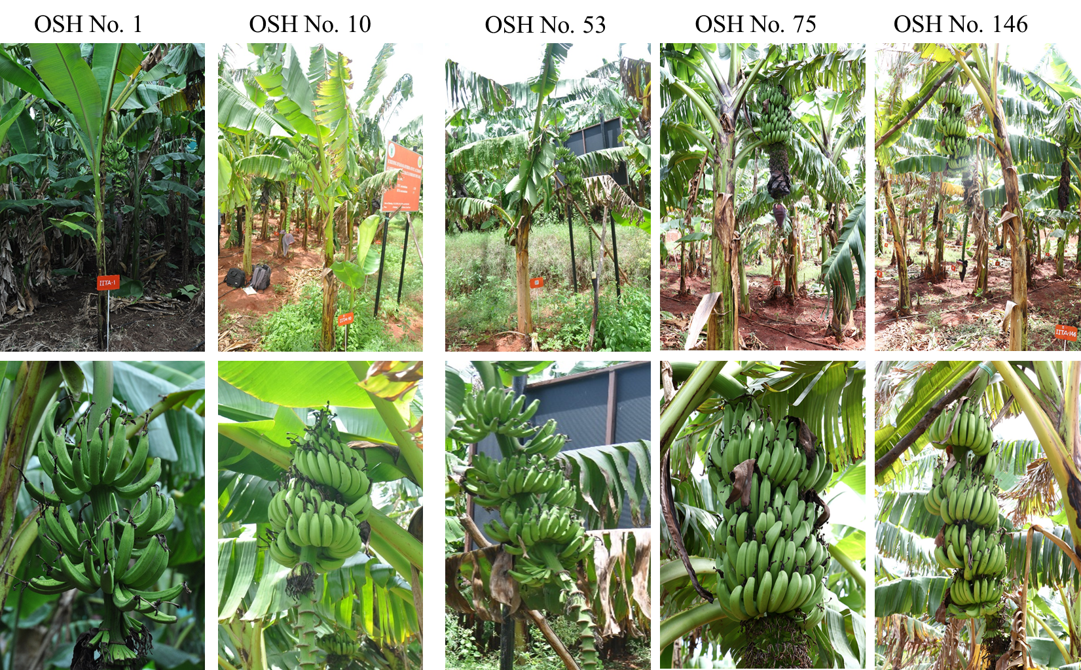
Figure 2.Field planted IITA hybrids

